Regional Operational Plan SF.2A.2018.XX

Operational Plan: Monitoring and Assessment of Anchorage Management Area Lakes, 2018–2021

by

Jay A. Baumer

Brittany J. Blain-Roth

Donald E. Arthur

and

Ben Buzzee

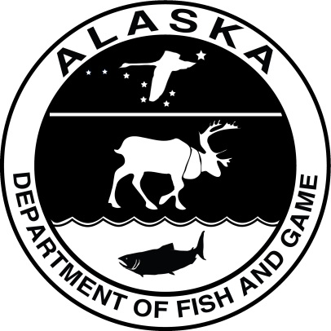

October 2018

Alaska Department of Fish and Game Divisions of Sport Fish and Commercial Fisheries

Symbols and Abbreviations

The following symbols and abbreviations, and others approved for the Système International d'Unités (SI), are used without definition in the following reports by the Divisions of Sport Fish and of Commercial Fisheries: Fishery Manuscripts, Fishery Data Series Reports, Fishery Management Reports, and Special Publications. All others, including deviations from definitions listed below, are noted in the text at first mention, as well as in the titles or footnotes of tables, and in figure or figure captions.

**Weights and measures (metric)**

centimeter cm

deciliter dL

gram g

hectare ha

kilogram kg

kilometer km

liter L

meter m

milliliter mL

millimeter mm

**Weights and measures (English)**

cubic feet per second ft3/s

foot ft

gallon gal

inch in

mile mi

nautical mile nmi

ounce oz

pound lb

quart qt

yard yd

**Time and temperature**

day d

degrees Celsius °C

degrees Fahrenheit °F

degrees kelvin K

hour h

minute min

second s

**Physics and chemistry**

all atomic symbols

alternating current AC

ampere A

calorie cal

direct current DC

hertz Hz

horsepower hp

hydrogen ion activity pH

(negative log of)

parts per million ppm

parts per thousand ppt,

‰

volts V

watts W

**General**

Alaska Administrative

Code AAC

all commonly accepted

abbreviations e.g., Mr., Mrs., AM, PM, etc.

all commonly accepted

professional titles e.g., Dr., Ph.D.,

R.N., etc.

at @

compass directions:

east E

north N

south S

west W

copyright ©

corporate suffixes:

Company Co.

Corporation Corp.

Incorporated Inc.

Limited Ltd.

District of Columbia D.C.

et alii (and others) et al.

et cetera (and so forth) etc.

exempli gratia

(for example) e.g.

Federal Information

Code FIC

id est (that is) i.e.

latitude or longitude lat or long

monetary symbols

(U.S.) $, ¢

months (tables and

figures): first three

letters Jan,...,Dec

registered trademark ®

trademark ™

United States

(adjective) U.S.

United States of

America (noun) USA

U.S.C. United States Code

U.S. state use two-letter abbreviations (e.g., AK, WA)

**Mathematics, statistics**

*all standard mathematical*

*signs, symbols and*

*abbreviations*

alternate hypothesis HA

base of natural logarithm *e*

catch per unit effort CPUE

coefficient of variation CV

common test statistics (F, t, χ2, etc.)

confidence interval CI

correlation coefficient

(multiple) R

correlation coefficient

(simple) r

covariance cov

degree (angular ) °

degrees of freedom df

expected value *E*

greater than >

greater than or equal to ≥

harvest per unit effort HPUE

less than <

less than or equal to ≤

logarithm (natural) ln

logarithm (base 10) log

logarithm (specify base) log2, etc.

minute (angular) '

not significant NS

null hypothesis HO

percent %

probability P

probability of a type I error

(rejection of the null

hypothesis when true) α

probability of a type II error

(acceptance of the null

hypothesis when false) β

second (angular) "

standard deviation SD

standard error SE

variance

population Var

sample var

Regional Operational plan SF.2A.2018.XX

**Operational Plan:** **Monitoring and Assessment of Anchorage Management Area lakes, 2018–2021**

by

Jay A. Baumer, Brittany J. Blain-Roth, Donald E. Arthur

Alaska Department of Fish and Game, Division of Sport Fish, Anchorage

and

Ben Buzzee

Alaska Department of Fish and Game, Division of Sport Fish, Research and Technical Services, Anchorage

Alaska Department of Fish and Game  
Division of Sport Fish, Research and Technical Services  
333 Raspberry Road, Anchorage, Alaska, 99518-1565

October 2018

The Regional Operational Plan Series was established in 2012 to archive and provide public access to operational plans for fisheries projects of the Divisions of Commercial Fisheries and Sport Fish, as per joint-divisional Operational Planning Policy. Documents in this series are planning documents that may contain raw data, preliminary data analyses and results, and describe operational aspects of fisheries projects that may not actually be implemented. All documents in this series are subject to a technical review process and receive varying degrees of regional, divisional, and biometric approval, but do not generally receive editorial review. Results from the implementation of the operational plan described in this series may be subsequently finalized and published in a different department reporting series or in the formal literature. Please contact the author if you have any questions regarding the information provided in this plan. Regional Operational Plans are available on the Internet at: <http://www.adfg.alaska.gov/sf/publications/>

Jay A. Baumer, Brittany J. Blain-Roth and Donald E. Arthur,

Alaska Department of Fish and Game, Division of Sport Fish,

333 Raspberry Rd. Anchorage, Alaska 99518-1599, USA

and

Ben Buzzee,

Alaska Department of Fish and Game, Division of Sport Fish, Research and Technical Services

333 Raspberry Rd. Anchorage, Alaska 99518-1599, USA

This document should be cited as follows:

Baumer, J. A., B. Blain, D. E. Arthur, and B. Buzzee. 2018. Operational Plan: Monitoring and assessment of Anchorage Management Area lakes, 2018–2021. Alaska Department of Fish and Game, Regional Operational Plan ROP.SF.2A.2018.XX, Anchorage.

The Alaska Department of Fish and Game (ADF&G) administers all programs and activities free from discrimination based on race, color, national origin, age, sex, religion, marital status, pregnancy, parenthood, or disability. The department administers all programs and activities in compliance with Title VI of the Civil Rights Act of 1964, Section 504 of the Rehabilitation Act of 1973, Title II of the Americans with Disabilities Act (ADA) of 1990, the Age Discrimination Act of 1975, and Title IX of the Education Amendments of 1972.

**If you believe you have been discriminated against in any program, activity, or facility please write:**

ADF&G ADA Coordinator, P.O. Box 115526, Juneau, AK 99811-5526

U.S. Fish and Wildlife Service, 4401 N. Fairfax Drive, MS 2042, Arlington, VA 22203

Office of Equal Opportunity, U.S. Department of the Interior, 1849 C Street NW MS 5230, Washington DC 20240

**The department’s ADA Coordinator can be reached via phone at the following numbers:**

(VOICE) 907-465-6077, (Statewide Telecommunication Device for the Deaf) 1-800-478-3648,

(Juneau TDD) 907-465-3646, or (FAX) 907-465-6078

**For information on alternative formats and questions on this publication, please contact:**

ADF&G, Division of Sport Fish, Research and Technical Services, 333 Raspberry Rd, Anchorage AK 99518 (907) 267-2375

Signature/Title Page

|  |  |
| --- | --- |
| Project Title: | Monitoring and Assessment of Anchorage Management Area Lakes, 2018–2021 |
| Project leader(s): | Jay Baumer, Brittany Blain-Roth |
| Division, Region and Area | Sport Fish, Region II, Anchorage Management Area |
| Project Nomenclature: |  |
| Period Covered | 2018–2021 |
| Field Dates: | 2018–2021 |
| Plan Type: | Category II |

**Approval**

|  |  |  |  |  |  |  |
| --- | --- | --- | --- | --- | --- | --- |
| Title |  | Name |  | Signature |  | Date |
| Project leader |  | Brittany Blain-Roth |  |  |  |  |
| Area Manager |  | Jay Baumer |  |  |  |  |
| Biometrician |  | Ben Buzzee |  |  |  |  |
| Research Coordinator |  | Timothy McKinley |  |  |  |  |

TABLE OF CONTENTS

Page

LIST OF TABLES iii

LIST OF FIGURES iii

LIST OF APPENDICES iii

Abstract 5

INTRODUCTION 5

Purpose 5

Background 5

Objectives 10

Primary Objectives 11

Secondary Objective 11

Methods 11

Primary Objective 1: Water Quality Monitoring 11

Study Design 11

Data Collection 12

Data Reduction 13

Data Analysis 13

Obective 2: Lake Mapping (Bathymetry) of AMA Lakes 13

Study Design 13

Data Collection 14

Data Reduction 15

Data Analysis 15

Objective 3: Population Assessment 15

Study Design 15

Data Collection 17

Data Reduction 18

Data Analysis 18

Objective 4: Identifying Food Sources and Consumption by Fish in AMA Lakes 20

Study Design 20

Data Collection 20

Data Reduction 21

Data Analysis 21

Secondary Objective: Develop a Creel Survey 21

Schedule and Deliverables 22

responsibilities 22

REFERENCES cited 23

Appendix A: History of Stocking in the Anchorage Management Area, 1996–2015. 24

Appendix B: Bathymetry and basic information for lakes targeted for sampling in the anchorage management area 35

Appendix C: Lake assessment data forms 45

# LIST OF TABLES

Table Page

Table 1.–Prescribed sampling effort according to lake size. 13

# LIST OF FIGURES

Figure Page

Figure 1.–Map of the common lakes and streams in the Anchorage Management Area including the names of stocked lakes. 6

# LIST OF APPENDICES

Appendix Page

Appendix A1.–Chinook salmon stocking in the Anchorage Management Area by year (1996–2015) and site. 22

Appendix A2.–Coho salmon stocking in the Anchorage Management Area by year (1996–2015) and site. 23

Appendix A3.–Rainbow trout stocking in the Anchorage Management Area by year (1996–2005) and site. 24

Appendix A4.–Rainbow trout stocking in the Anchorage management Area by year (2006–2015) and site. 27

Appendix A5.–Arctic char stocking in the Anchorage Management Area by year (1996–2015) and lake. 30

Appendix A6.–Arctic grayling stocking in the Anchorage Management Area by year (1996–2015) and lake. 31

Appendix B1.–Bathymetric map and basic information for Campbell Point Lake in the AMA. 33

Appendix B2.–Bathymetric map and basic information for Cheney Lake in the AMA. 34

Appendix B3.–Bathymetric map and basic information for DeLong Lake in the AMA. 35

Appendix B4.–Bathymetric map and basic information for Gravel Pit Lake in the AMA. 36

Appendix B5.–Bathymetric map and basic information for Jewel Lake in the AMA. 37

Appendix B6.–Bathymetric map and basic information for Lower Fire Lake in the AMA. 38

Appendix B7.–Bathymetric map and basic information for Mirror Lake in the AMA. 39

Appendix B8.–Bathymetric map and basic information for Sand Lake in the AMA. 40

Appendix B9.–Bathymetric map and basic information for Waldron Lake in the AMA. 41

Appendix C1.–Datasheet used to record water quality measurement. 43

Appendix C2.–Datasheet used to record data on individually captured fish and for recording netting effort and gear type. 44

Appendix C3.–Datasheet used to record a tally of total catch by species and fishing time for each piece of sampling gear. 45

Appendix C4.–Datasheets used to record macroinvertebrate collection and identification data. 46

Appendix C5.–Datasheet used to record stomach contents for prey assessment. 47

# Abstract

Many Anchorage area lakes have been stocked annually with hatchery fish since the 1950s to provide anglers local fishing opportunities and alternatives to fishing the area’s scant wild stocks, which are susceptible to overharvest due to high angler participation and easy accessibility from the City of Anchorage. The local stocked lakes fisheries are anecdotally very popular, but the lakes have had very little monitoring or assessment of water conditions and fish health after stocking because many of these local lakes are man-made and assumed to be put-and-take fisheries. However, to maximize the success of stocking for the fishery, lake-specific information is needed to determine if lake conditions are suitable for the current stocking levels and stocking practices This information will provide area biologists and managers with information to make more informed decisions about stocking Anchorage Management Area (AMA) lakes. Additionally, this project will establish a baseline for stocked lake conditions in the AMA for future investigations as well as provide ground work for a future creel survey to better understand angler effort. During this exploration, lakes that are not currently stocked will be investigated to determine suitability for future stocking, including a documentation of food resources and which species would be most suitable to stock. Results from this project will be made available to the public through information handouts, the ADF&G website, as well as in a Fisheries Data Series report.

Key words: Anchorage, Anchorage Management Area, stocking evaluations, stocking strategy, lake monitoring and assessment.

# INTRODUCTION

## Purpose

The purpose of this project is to assess a select number of lakes in the Anchorage Management Area (AMA) to determine select water chemistry and quality variables, assess fish populations and stocking success, and gather some information about angler use patterns. Assessment will include the collection of AMA lake water quality and physical conditions, fish health, and fish food availability. We will also evaluate the growth, health, and survival of stocked fish populations in the lakes of the AMA. These objectives, coupled with informal creel surveys to estimate effort, catch, and harvest, will provide the framework for a more thorough creel survey and sampling protocol which will help determine the success of the current stocking strategy and sportfishing regulations in the AMA. Current assessment of lakes in the AMA comes only from what is reported in the Alaska Department of Fish and Game (ADF&G) Statewide Harvest Survey (SWHS).

## Background

There are currently 26 stocked lakes in the Anchorage Management Area (AMA). These stocked lakes can be categorized into 4 subunits based on their general location in the AMA: Anchorage Bowl, Chugiak–Eagle River, Joint Bases Elmendorf–Richardson (JBER), and Turnagain Arm (Statewide Stocking Plan)[1]. Anchorage lakes are widely distributed, ranging from as far south as Portage Valley Road to the community of Chugiak in the north (Figure 1). Anchorage is Alaska’s most populated city so AMA lakes serve a large, diverse population. AMA fishing experiences range from fishing an urban neighborhood lake to remote fisheries in the Chugach Mountains, such as Rabbit and Symphony lakes. AMA lakes can range in size from as small as 4 acres (Triangle Lake) to as large as 125 acres (Otter Lake). APU–University Lake is unique in that it is part of the Chester Creek drainage. These varying features amongst all AMA lakes results in each lake providing a unique experience for the angler, but also very different environmental conditions that can affect stocked fish populations.

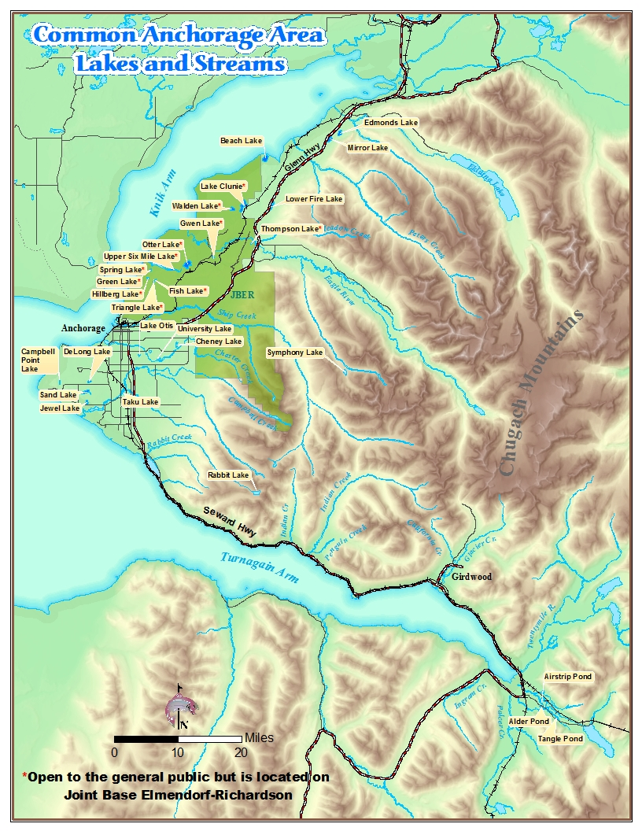

Figure 1.–Map of the common lakes and streams in the Anchorage Management Area including the names of stocked lakes.

Historically since the late 1950s, primarily 2 fish hatcheries (Fort Richardson Hatchery and Elmendorf Hatchery), both located on Ship Creek, have provided fish for stocking in the AMA. The Fort Richardson hatchery was built in 1958 by the U.S. Army to provide fish for lakes on the Department of Defense (DOD) property. ADF&G became involved in the early 1960s and assumed full operation of the Fort Richardson Hatchery facility by the late 1960s. The Fort Richardson Hatchery sits on the banks of Ship Creek, just downstream of the Glenn Highway (ADF&G website Fort Richardson State Fish Hatchery; http://www.adfg.alaska.gov/index.cfm?adfg=fishingSportStockingHatcheries.ftrichardson, accessed December 2016) and approximately 5 miles upstream from the Elmendorf Hatchery. The Elmendorf State Hatchery started in 1965 and was located in Anchorage on the north bank of Ship Creek near the intersection of Reeve Boulevard and Post Road (ADF&G website Elmendorf State Fish Hatchery; http://www.adfg.alaska.gov/index.cfm?adfg=fishingSportStockingHatcheries.elmendorf, accessed December 2016).

The permanent loss of heated effluent from the Fort Richardson (2003) and Elmendorf (2005) power plants resulted in a reduction in fish size and number of catchable-sized fish released from the hatcheries in 2005 to 2011. The catchable rainbow trout (*Oncorhynchus mykiss*) program shifted from producing 1-year-old catchable fish to producing 3-year-old catchable fish and 2-year-old undersized catchable or “subcatchable-sized” fish. The closure of Elmendorf Hatchery in 2010 resulted in the release of rainbow trout fingerling into local lakes. The catchable Chinook salmon (*O. tschawytscha*) program saw reductions in fish size, number of fish released, and number of lakes stocked starting in 2006 when an outbreak of bacterial kidney disease, also known as BKD, in the Chinook salmon at Fort Richardson Hatchery resulted in the release of fingering instead of catchable Chinook salmon that year. In addition, from 2007 to 2009, only Category 1 (landlocked) lakes were permitted for releases of catchable-sized fish from Elmendorf Hatchery after an Oregon State University graduate student reported the presence of DNA from the parasite, Myxobolus cerebralis, that causes whirling disease was found in a rainbow trout in the Elmendorf Hatchery (Arsan et al 2007) . Catchable-sized Chinook salmon were not released in 2010–2011. Due to disease concerns, catchable-sized Arctic grayling (*Thymallus arcticus*) production ceased in 2002. Arctic grayling fingerling and subcatchable-sized fish were released from 2003 to 2012. The stocking of Arctic grayling into Symphony Lake was discontinued in 2003; however, this lake maintains a self-sustaining population of relatively small fish. A small group of AMA lakes were historically stocked with Arctic graying but this program was discontinued in 2015.

In June 2011, construction of the new William Jack Hernandez Sport Fish Hatchery (WJHSF Hatchery) was completed. With over 100 rearing tanks, this hatchery can produce over 6 million sport fish each year to stock throughout permitted areas of Alaska. The rainbow trout and Chinook salmon catchable production programs returned to historical stocking levels when the first catchable-sized fish were released from the WJHSF Hatchery in 2012. The new WJHSF Hatchery uses more advanced recirculating aquaculture systems to produce healthier and stronger “products.” In addition, the first release of catchable-sized Arctic grayling from WJHSF Hatchery occurred in 2013; however, due to budget restrictions, the Arctic graying stocking program was suspended indefinitely after stocking in 2015 to reduce operating expenses (Statewide Stocking Plan). The lakes in the AMA are currently stocked primarily with catchable rainbow trout, Arctic char (*Salvelinus alpinus*), and Chinook salmon from the WJHSF Hatchery. The grayling stocking program has been revitalized and is scheduled in 2019 to restock lakes that have historically been stocked with Arctic grayling

The primary purpose of the nonanadromous stocking program is to provide diverse year-round fishing opportunities to the general public and alleviate fishing pressure that would otherwise be directed towards wild stocks (Statewide Stocking Program). Stocking records for AMA lakes over the last 5 years (2013–2017) can be found in Appendices A1–A6. Four other fish species are known to be present in some but not all AMA lakes: three-spined stickleback (*Gasterosteus aculeatus*), longnose sucker (*Catostomus catostomus*), Alaska blackfish (*Dallia pectoralis*), and northern pike (*Esox lucius*).

The species and number of fish stocked in each lake is determined by lake morphometry and angling pressure, as well as the availability of fish at the WJHSF Hatchery. For example, activity in Arctic char has been documented to decrease dramatically when water temperatures exceed 10°C, therefore Arctic char are only stocked in 6 AMA lakes that provide a thermal refuge through relatively large average or maximum depths. Conversely, rainbow trout can tolerate greater thermal and dissolved oxygen (DO) concentration ranges and as a result are stocked routinely in all 26 of the currently stocked lakes. All currently stocked lakes are stocked annually except Rabbit Lake, which is scheduled to be stocked every odd year due to its remoteness. Some lakes have supplemental stockings of larger Arctic char and rainbow trout broodstock to add a new dimension to the stocked lake fisheries in the AMA.

Each year, new lakes are suggested or proposed as candidates for stocking and some lakes have stocking discontinued for various reasons. For example, in 2014, stocking was discontinued in Lower Fire Lake because of a known, active population of northern pike. In an effort to reduce the northern pike population, ADF&G halted the stocking of rainbow trout, which is a prey item of northern pike. In other AMA lakes, northern pike have been eradicated and stocking has been resumed (e.g., Otter Lake on Joint Base Elmendorf–Richardson). New improved public access to a lake may also provide an encouraging reason to stock fish. These kinds of lakes should be assessed prior to being added to the stocking plan.

To determine if a lake should be stocked (whether it was stocked historically or not), effective stocking requires a protocol to determine the timing, species, and quantity of stocked fish that would benefit anglers and their fishing experience. Current means for assessing the success of a stocking strategy is limited to comparing annual SWHS data to the objective goals in the Statewide Stocking Plan for the AMA. The SWHS is a mail-out survey that produces estimates of annual effort, catch, and harvest for a various waterbodies in Alaska, including the AMA lakes. The goals in the Statewide Stocking Plan are defined as a minimum level of angler-effort that provides diverse, year-round fish opportunities. Unfortunately, angler responses for some of the AMA lakes are at times low and sporadic; therefore, estimates can fluctuate greatly from year-to-year (Baumer and Blain 2017). For an individual lake to be reported on the SWHS, the lake must receive 12 mail-in responses (Alaska Sport Fishing Survey database [Internet]. 1996–present. Anchorage, AK: Alaska Department of Fish and Game, Division of Sport Fish (cited May 1, 2018). Available from: http://www.adfg.alaska.gov/sf/sportfishingsurvey/). Often, an individual AMA lake does not receive enough responses to be published in the SWHS report and a site-specific creel survey is necessary to assess the lake.

Although not currently in place, a creel survey is needed to collect data on effort, catch, harvest, and demographics of anglers using AMA lakes. A secondary goal of this project is to determine the best way to conduct a creel survey across a select number of Anchorage lakes to estimate effort, catch, and removals, as well as other catch data and information from anglers. A creel survey was performed by in 1986 (Havens 1986) for 4 AMA lakes, but since then there have been improvements to the stocked products and the population of Anchorage has greatly changed. Therefore, creel information that is over 30 years old may no longer be relevant today. A contemporary creel survey is needed to help define current stocking strategies. Basic abiotic (e.g., water quality) and biotic (e.g., stocking) data can be juxtaposed to the creel survey data to reveal valuable information, such as explanations for high or low catches. Thus, creel survey data will be integral to overall assessment of stocked lakes in the AMA. .

Additional project objectives include the assessment of select stocked lakes for annual trends in select water chemistry and quality variables, lake morphometry and physical characteristics, and fish populations. Water quality monitoring, bathymetric mapping, and single-event netting will be used to meet these objectives. All the data collected from this assessment will be compiled and presented to Anchorage area managers and organized for the Sport Fish Information Center staff to provide information to the general public through brochures and the Alaska Lake Database (ALDAT).

# Objectives

## Primary Objectives

The primary goal of this project is to document and monitor biotic and select abiotic factors that could impact sportfish species in AMA lakes. The following objectives must be met to achieve this goal.

1. Monitor dissolved oxygen (DO), temperature, clarity, and pH at 2 locations on 9 AMA lakes throughout the year to identify seasonal trends.
2. Generate bathymetric maps and lake images for 6 unmapped lakes in the AMA to use for managing, fishing, or stocking the lake.
3. Assess the presence of fish species in 4 AMA lakes, and if present, generate histograms of lengths and bar plots of ages for each species, and assess the overall health of stocked fish species using Fulton’s Condition Factor (K) with 95% confidence when *n* ≥ 30 in a given sampling event.
4. Identify the presence of food resources using D-frame dip nets and an Eckman dredge for benthic sampling in 4 AMA lakes that are assessed for presence of fish (Objective 3), and assess the consumption of food resources in the stomach contents of captured stocked fish species in stocked AMA lakes.

## Secondary Objective

The secondary objective of this project is to develop objectives and methods for a future AMA creel survey.

# Methods

## Primary Objective 1: Water Quality Monitoring

### Study Design

Water quality samples will be collected on 9 lakes in the AMA in 2018 and 2019. Specifically, dissolved oxygen (DO), temperature, clarity, and pH will be collected at each lake described in Appendices B1–B9. Each lake will be sampled 1–2 times per month, as conditions allow. Frequent monitoring will help identify seasonal trends. With this sampling frequency, we should be able to determine times of oxygen minimums and temperature maximums as well as rates of oxygen depletion during the winter, times of cooling and warming, and periods of vertical lake mixing, such as spring and fall turnover.

Nine lakes have been selected for water quality monitoring:

1. Campbell Point Lake
2. Cheney Lake
3. DeLong Lake
4. Lower Fire Lake (not currently stocked; water quality sampling will only be conducted on a monthly basis)
5. Gravel Pit Lake (not currently stocked; water quality sampling will only be conducted on a monthly basis)
6. Jewel Lake
7. Mirror Lake
8. Sand Lake
9. Waldron Lake (not currently stocked; water quality sampling will only be conducted on a monthly basis)

Sampling for each lake will occur at 1 location near the deepest depth of the lake (Zmax) and 1 location in a shallower or littoral zone at easy access points (Appendices B1–B9). In the summer, this will require launching a canoe or kayak. A global positioning system (GPS) will be used when accessing sampling locations to maintain consistency each time sampling occurs. Additional AMA lakes may be sampled opportunistically, possibly resulting in a more widespread distribution of sampled lakes.

### Data Collection

A *YSI Pro Plus[2]* with a multiparameter *Pro1020 Sonde* will be used to measure water quality parameters at a lake sampling locations. The *Pro1020 Field Cable* will be equipped with accessory DO and pH sensory probes, and a temperature sensor that is integrated into the design of the cable. Temperature (°C), pH, barometric pressure (mmHg), and both DO concentration (mg/L) and saturation (%) readings will be recorded every 0.5 m from the surface down to the lake bottom. Water quality sampling on the lakes close to the Anchorage ADF&G office will occur bimonthly throughout the year, as conditions allow. The time required for travel to more distant lakes may only allow for water quality sampling once per month at these locations. Additional water quality sampling events may occur opportunistically, if technicians are conducting other sampling or events on a stocked lake.

2d[Koenings et al. 1987](#_ENREF_6" \o "Koenings, 1987 #4804)

will()

### Winter sampling will require drilling an ice hole with a powered auger. An auger bit with a diameter of 20.3 cm (8 in) or greater will be used to accommodate the 20 cm diameter Secchi disk used to assess water clarity. Ice thickness and snow cover will be recorded during sampling when the lakes are iced up. If lake ice is unsafe or known to be less than 10 cm thick, sampling will be deferred until conditions are safe.

### Data Reduction

Upon returning from the field, water quality data will be entered into a Microsoft Excel spreadsheet for each corresponding lake. Other notes and observations will be entered and saved within the same spreadsheet. The Secchi depth will be entered as the average of the depth where the disk disappeared and reappeared. Data will be reviewed for errors by the field crew leader. The crew leader will create depth profiles of water temperature, DO, and pH in Microsoft Excel and those graphics will be saved in the same files as the associated spreadsheet.

### Data Analysis

Water temperature, DO, pH, and clarity will be assessed for seasonal trends, drastic changes, and periods when water quality parameters are not ideal for stocked fish species. Seasonal highs of water temperature and low DO concentration will be determined for each lake. Based on water quality data, including Secchi depth, lakes will be identified that may experience turnover or winter kill events.

Water quality data will be used to determine if stocking dates are appropriate or if stocking dates need to be adjusted to accommodate lake conditions for the fish. It is important to identify if a given lake provides the range of DO and temperatures that are suitable for stocked fish survival. Proposed stocked lakes will be evaluated following the same water quality criteria.

## Obective 2: Lake Mapping (Bathymetry) of AMA Lakes

### Study Design

The depths of many of the stocked lakes in the AMA have already been sampled to creating bathymetric maps (e.g., Appendices B1–B9). The recent mappings were completed using new sonar technology produced by Lowrance. Using this method, the maps have a finer resolution than previous techniques such as the hand-line method. Bathymetric maps created from sonar data can provide vital information to make decisions on stocking, future project designs, and improve anglers fishing knowledge. Field crews will need bathymetric maps to find sample locations for water quality monitoring and to determine netting locations.

Morphometric values such as maximum depth (Zmax), mean depth, shoreline length, surface area, and volume can be calculated from sonar data. These data can be used to assess a lake for management purposes because lake morphometry affects water chemistry and productivity, and in turn, affects the suitability for fish. Other physical characteristics such as inlets and outlets, man-made structures, and public access are included on the bathymetric maps produced by ADF&G because this information is useful to anglers and the management of these lakes.

The ADF&G, Division of Sport Fish (SF) will continue mapping stocked lakes in the AMA. Only 2 currently stocked lakes have not been mapped yet: Lower Six Mile and Rabbit lakes. Additional AMA lakes that have not been stocked or are no longer stocked will also be mapped under the same methodology. The list of lakes that will be mapped for this project are as follows:

1. Lower Six Mile Lake
2. Psalm Lake (not currently stocked)
3. Reflections Lake (not currently stocked)
4. Rabbit Lake
5. Sundi Lake (not currently stocked)
6. Upper Fire Lake (not currently stocked)

### Data Collection

A Lowrance HDS-7 chart plotter equipped with an internal 10Hz GPS antennae will be used to collect location data in decimal degrees and depth data in feet. Traditional sonar and Structure Scan transducers will be used in conjunction with the HDS-7 unit to collect depth sounding data (ft). The transducers will be mounted on a piece of PVC-pipe and a short piece of 2 × 10 inch wood, so that it can be clamped and used on boats with varying sized transoms. A 2-person crew is needed to conduct data collection safely. One person will operate the vessel while the other manages the Lowrance unit and watches for shallow (<0.3 m) areas of the lake. The Lowrance is manually programmed to record paired depth and GPS location data as the boat is underway. The data will be saved as a .sl2 file onto an external storage (SD) card.

While maintaining a speed of less than 10 km/hr, the vessel operator will make an initial transect around the shoreline of the lake, avoiding sections of the lake less than 0.3 m deep. From there, transects will either be made in concentric circles towards the center of the lake, if the lake is less than 30 acres in size, or transects will be made perpendicular to the longest shoreline and with spacing no greater than 25 m apart, for lakes greater than 30 acres in size. The operator of the Lowrance will monitor depths during the entire process to document areas with underwater structures, such as channels or drop-offs; if such structures are found, several parallel transects will be made over these structures. Prior to departure from the lake, the crew will measure the depth of the transducers below the lake surface and record this in a waterproof notebook; this is referred to as the transducer offset.

While collecting data, the crew will look for inlet and outlet streams, as well as features that should be documented on the bathymetric map. These features are also important for determine the stocking category for the lake. GPS locations for all features will be recorded in a notebook. Photographs will be taken at all main public access locations on the lake as well as other features of the lake.

### Data Reduction

The .sl2 files collected from the lake will be organized and renamed in a format that includes the lake name and the file number in sequential order of the time it was recorded. Notes and offsets for each file will be written up in a word file and saved with the corresponding sonar files. The sonar files will be submitted to ciBioBase, an online lake-mapping software. ciBioBase extracts the depth and GPS location data from the .sl2 files. The data can then be downloaded from the website and saved in an excel spreadsheet.

### Data Analysis

ADF&G Analysts will use the depth data plotted in a geographic information system (GIS) with GPS coordinates and overlay it on a satellite image of the subject lake. Inlets, outlets, public access, and other features will be plotted on the map with the depth layer. The maps will be reviewed for accurate depth readings and appropriate cartography. Maximum depth (Zmax), mean depth, shoreline length, surface area, and volume will be estimated for each map. A final draft of each map will be submitted to area management biologists with a table of morphometric values. Bathymetric maps as well as photographs of the lake access will be uploaded to ALDAT.

## Objective 3: Population Length Frequency Distribution and age structure

### Study Design

There is currently very little knowledge about the survival and growth of stocked fish in the AMA lakes. AMA lakes are commonly thought of as strictly put-and-take lakes, but there are not enough empirical data to support or deny this claim with current stockings from the WJHSF hatchery. An assessment of survival, seasonal growth, and mean condition of stocked fish will help with management of AMA lakes.

Single-day sampling events that occur twice a year will be used to determine a spring and fall population length frequency distribution (LFD) and mean length for each stocked species for each lake sampled. Each lake will be sampled for over the course of 2 years to allow better understanding of overwinter survival. The first sampling event will occur in the spring after ice breaks up on the lake but prior to the summer stocking activities commence. The second sampling event will be in the fall prior to ice forming on the lake and prior to the fall stocking which is intended to enhance the number of fish in the lake during the winter months for ice fishing. Sampling events will be coordinated with the hatchery staff to make sure stocking does not occur before fish sampling events.

Fish sampling will only occur when surface (less than 1 m) water temperatures are less than 18°C to reduce stress on the fish being sampled and to make sure the distributed of fish is even throughout the lake do to warm water on the surface (Skaugstad and Behr 2016). Water temperature 1 m below the surface will be measured and recorded at the time of sampling.

During sampling events a combination of fyke nets, variable-mesh gillnets, seine nets, and minnow traps will be deployed in varying quantities and for 24 hours on the selected lake. The surface area of an individual lake will determine the prescribed effort (Table 1), but each lake may have constraints, such as remoteness or presence of waterfowl that may result in sampling effort that differs from that prescribed in Table 1. These particular constraints will be identified during the event planning period and a site visit in the days prior to a sampling event. To document any differences from the prescribed effort, soak time for each net or trap will be recorded along with the associated catch for that net or trap on a datasheet (Appendix C2). Supplemental rod-and-reel sampling may occur while nets are fishing, and effort and catch will be recorded for this gear type similarly.

Table 1.–Prescribed sampling effort according to lake size.

|  |  |  |  |  |
| --- | --- | --- | --- | --- |
| Hectares (acres) | Days | Fyke nets | Gillnets | Minnow traps |
| 0–10 (25) | 1 | 4 | 4 | 4 |
| >10–20 (50) | 1 | 4 | 4 | 6 |
| >20–40(100) | 1 | 6 | 4 | 8 |
| <40 (100) | 1 | 8 | 4 | 10 |

Fyke nets will be set in the nearshore environment and target fish migrating in water shallower than 2 m. The openings of the fyke nets are composed of two 0.9 m tall by 1.2 m wide aluminum frames and are followed by 5 galvanized hoops. Each net has two 25 m long wings that extend to form a “V” shape to funnel fish into the cod end. The selection of specific habitat to target and spacing will be determined by the crew leader based on weather and the knowledge of fish movement, and the fyke nets will be set prior to any other sampling gear and will be pulled at approximately the same time the following day (24-hour soak).

Minnow traps, also referred to as juvenile fish traps, are approximately cylindrical in shape. The traps used for this project are approximately 42 cm in length, have a diameter of 22 cm, and funneled ends with 3 cm entrance holes. The minnow traps will be set uniformly throughout the lake, and will target a variety of habitats. Most traps will be set resting on the lake bottom, whereas some may be set suspended in the water column. Resting traps will be tied off to a secure object on shore or to a buoy. Suspended traps will be attached to a buoy line and well-anchored.

While the minnow traps and fyke nets are fishing, the crew will work and closely monitor gillnets or a seine net. These nets will be closely monitored when waterfowl or swimming pets are present. Two gillnets will be fished at shallow depths and near the surface; these nets are called “floaters.” The other 2 gillnets will be fished at deep depths (>2 m) with a heavier lead-line to sink the net; these gillnets are called a “sinkers.” These nets are 15 m long and 2 m deep, consisting of three, 6 m hung panels of variable mesh of three-quarter, 1, and 1½ inches. The gillnets will be set and alternately checked within 30 minutes of deployment in order minimize fish mortality. As nets are checked, they may be reset in a new location or remain in the same spot; however, GPS location as well as pull and set times will be recorded for each set. Similar information will be collected when using the seine net but this will be actively run by staff. This type of gear misses fish at depths deeper than 6 ft, but the small mesh size allows for the collection of all varieties of stocked fish and some smaller native fish.

Nets and traps will be deployed primarily from an open skiff, an inflatable raft, or a canoe. A crew of at least 2 personnel will be required to safely and effectively set nets. If there are additional crew members, this will allow for sampling with rod-and-reel, quicker response to incidents, and more frequent sets of gillnets. The importance of recording set and pull times and GPS locations will be emphasized to the crew. A waterproof copy of the bathymetric map and a GPS unit will be provided to crews to determine and document where nets and traps are set. Netting data will be recorded on the datasheets in Appendices C2 and C3. Depth that a trap is set will also be recorded and will be measured using a handheld depthfinder.

As fish are removed from a net or trap, captured fish will be identified and sorted into separate live buckets or totes containing aerators. The fish from one net or trap will be sampled prior to pulling the next.

Sampling events will take place in the following lakes:

1. Campbell Point Lake
2. DeLong Lake
3. Jewel Lake
4. Lower Fire Lake (not currently stocked)

Campbell Point Lake has been selected as the first lake to be sampled. After sampling techniques will be assessed and modified before proceeding to sample other AMA lakes. DeLong and Lower Fire lakes will be sampled in the next round of lakes to be sampled. These lakes were chosen because DeLong Lake is believed to be one of the most fished lakes in the AMA, and Lower Fire Lake is no longer stocked due to the presence of northern pike and may be treated with Rotenone within the next few years to eradicate northern pike therefore this lake needs pretreatment documentation to assess posttreatment changes.

### Data Collection

For each sampling event, all captured stocked fish will be identified and measured from tip of snout to fork of tail (FL) using a handmade fish-measuring board. Lengths will be recorded to the nearest millimeter. In addition, all stocked fish over 150 mm will be weighed using a Pesola metric spring scale with weighing sling. Three scales from the “preferred area” ([Clutter and Whitesel 1956](#_ENREF_3" \o "Clutter, 1956 #1677)) will be collected using forceps and placed on scale cards for all salmonids that are captured. Scale card data along with length and weight measurements for each sport fish will be recorded on the corresponding net datasheet used to record its capture (Appendix C2). General health, any abnormalities, and other notes about the fish will be recorded as well.

For nonsport species, the first 30 individuals from each gear type will be measured (FL) and the rest of the fish will be simply counted to determine the total number of fish captured. The tally, including the fish that are sampled for length, will be recorded on a separate datasheet (Appendix C3). Any invasive species captured in AMA lakes will be immediately dispatched and retained. Location and other information pertinent to the capture will be recorded and relayed to the ADF&G Anchorage area management biologists and invasive species coordinator upon return from the field.

Prior to release of (noninvasive) captured fish, each fish will receive a Floy tag and (or) an unobtrusive marking. Each stocked fish will receive a Floy tag and the number will be recorded with the length, weight, and scale card data associated with the same fish (Appendix C2). All captured (including nonsport) fish will receive a half-circle mark on the upper lobe of the caudal fin with a 7 mm paper punch as described in Behr (2017); this is intended to prevent the sampling or tallying of the same fish twice in the same sampling event. If a marked or tagged fish is captured in the subsequent fall sampling, length, weight, condition of the fish, and scales will be collected again the Floy tag number will be recorded. Signs will be placed at all access points notifying the public of who to contact if a tagged fish is caught.

### Data Reduction

The length and weight data from the fish sampling events will be compiled into a lake-specific Microsoft Excel spreadsheet for analysis. The project biologist will review the spreadsheet for any data entry errors and outliers. Maps will be generated with locations where nets and trap were set in each lake. Netting effort will be entered into an additional tab on the Excel spreadsheet. Effort will be summed by each gear type.

The scale cards will accompany each corresponding datasheet (Appendix C2). Scales will be pressed onto acetate cards and the scale impressions on the acetate cards will be read using a microfiche reader (Clutter and Whitesel 1956). Aging of scales will be conducted by the field crew leader. Scales can be used to age a fish since its stocking event; this will be called the “scale age.” Most stocked fish in the AMA spend the first year of their life or more in the hatchery, and in that time they are not exposed to the slow growth experienced by wild fish during the winter months. Due to steady temperatures and food supply, hatchery fish scales are not expected to produce winter “checks” or annuli during this time; therefore, the scales will be used to determine how many years since the fish had been stocked. A fish’s hatchery history can be determined from a known stocking year, allowing us to calculate a fish’s true age based on how many years it spent in the hatchery. Both scale age and true age will be entered for each fish into the Microsoft Excel spreadsheet.

### Data Analysis

Scales will be examined for winter annuli to track an individual fish back to a stocking year and to calculate its true age. The presence of annuli will indicate winter survival and possibly long term survival of stocked fish. Analysis of scales may also be used to reveal natural reproduction in lakes where historical diploid stocking occurred (based on scale age and stocking history) or in lakes with wild fish (based on scales that have radiating annuli).

Sampling data from all gear types will be used to establish species present in sampled AMA lakes. Age structure plots and length frequency distributions (LFD) and will be created for all species by gear type to aid with identifying age or stocking cohorts. The histogram function in MS Excel will be used to enumerate each stocked species that fall within 10mm length categories. Length categories will start at 0 mm and increase by 10 mm intervals (e.g., 0, <10 mm, 10 to <20 mm, etc.) the last length category for a data set will include the largest fish. This information will be used to create column, chart to illustrate the population LFD.

Using length fish capture data the mean length ($\overline{x}=\sum_{i=1}^{n}{\frac{x_{i}}{n}})$ of fish captured and corresponding sample variances ( $\hat{var(\overline{x})}=\frac{s^{2}}{n}$ where $s^{2}=\sum_{i=1}^{n}{\frac{{(x_{i}-\overline{x})}^{2}}{n-1}})$ will be calculated for each sampling event.

## Objective 4: Identifying Food Sources and Consumption by Fish in AMA Lakes

### Study Design

Forage availability for the 4 lakes sampled for fish (see Primary Objective 3) will be determined with a summary of macroinvertebrates families found in samples from each lake. Additionally, data collected from minnow trapping will be used to determine fish species that are potentially consumable by a stocked fish. Any fish ≤150 mm captured in a minnow trap will be considered a possible prey item for stocked fish. Diversity and abundance of macroinvertebrates and prey fish can be used as an indicator of lake productivity and ability to sustain a population of 1 or more species of stocked fish. The assessment of food availability and consumption will be conducted during netting events or when time is available throughout the summer months.

### Data Collection

Macroinvertebrates will be collected throughout the littoral zone of each lake using D-frame dip nets. Samples will be collected from 4 evenly spaced locations around the shoreline of the lake. Two samplers will work each station for 5 minutes, dragging dipnets through macrophytes, woody debris, and substrate. A timer will be used to keep track of each 5-minute sampling period. When time expires, samples will be collected in Whirl-pak baggies and preserved in 70% ethanol. Each Whirl-pak baggie will be labeled with the date, name of the lake, and sample station number. One additional sample will be collected at the deepest location of each lake using a ponar or benthic grab; this sample will stored in a Whirl-pak baggie and labeled “Benthic Grab.”

A subsample of 50 individual organisms from each site will be used to document species presence. The process for selecting the subsample will match the procedure described in Mansfield and Behr (2011). The entire sample from a Whirl-pak baggie will be poured out and spread on a white tray. A 30-square grid will be placed over the tray, and each square assigned a sequential number. Using a randomly generated number, the corresponding grid square will be sampled for 50 individuals. If 50 individuals are not collected in the first subsample, an additional grid will be selected (randomly) and sampled (Mansfield and Behr 2011). Using dichotomous keys in *Freshwater Macroinvertebrates of Northeastern North America* and *An Introduction to Aquatic Insects of North America*, the 50 individuals will be identified with a dissecting microscope to family, or a lower taxonomic level if necessary. This procedure will be repeated for all 4 sample stations and the benthic grab. As macroinvertebrates are identified, sample station information and individual organism identification will be recorded on a datasheet (Appendix C4).

Stomach contents of stocked fish will be collected in 2 ways. The first technique is nonlethal and will be employed to pump the stomach contents from a subsample of stocked fish captured during netting (Primary Objective 3). Every 5th rainbow trout, Chinook salmon, and Arctic char with fork length greater than 150 mm caught during netting will be sampled for stomach content until a sample size of 20 for each species is obtained for each sampling event. A pump will be used to extract stomach contents from live fish. Any fish mortalities that occur as result of net capture will be dissected to extract stomach contents. All captured northern pike will be sacrificed and dissected for collection of stomach contents as well. The entire stomach content of each fish will be stored in an individual scintillation vial and preserved in 70% ethanol. The vial will be labeled with the species, fish sample number, date, and sampling location; all data will be recorded on a sampling datasheet (Appendix C5). Some stomach content can be partially digested and difficult to identify. In some cases, insects, fish, and other organisms can be identified down to family or even lower taxonomic levels if the prey item is recently consumed. Well-digested items may be identified at a more general level such as “fish” or “adult insect,” or labeled as unidentified. A stomach content datasheet (Appendix C5) will be used to record stomach content data for each fish.

### Data Reduction

After macroinvertebrates, forage fish, and stomach contents are identified and recorded, these data will be manually entered into worksheet tabs labeled “Food Availability” and “Diet Analysis” for each lake’s Microsoft Excel file. Macroinvertebrate identification and tallies will be entered for each sampling station. Minnow trapping data (number of fish by species) will be added to the macroinvertebrate data in the “Food Availability” tab. A list of stomach contents will be entered for each fish Along with the method used to collect those contents (pump or dissection). If a stomach is found to be empty, or extraction is unsuccessful, this will be noted in the excel file as well.

### Data Analysis

A list of sampled macroinvertebrates and forage fish will be generated for lake. Stomach content data will be examined to determine the portion of available forage types consumed by each stocked fish species. Low consumption can be explained by environmental stress or lack of preferred diet of stocked fish species. Differences in diet will be evaluated between lakes for each stocked fish species. Prey preferences and prey abundances could provide insight when considering stocking in AMA lakes.

## Secondary Objective: Develop a Creel Survey

In order to develop an AMA creel survey operational plan, we will work with hatchery and sport fish information staff to decide on a reasonable timeline for implementation of an AMA creel survey, identify creel survey questions, decide how to contact anglers and collect creel survey information, identify incentives to help anglers complete a survey, identify sampling locations and interview schedules, and develop an outreach plan for the creel efforts. In addition, as ADF&G staff work to complete the other parts of this project, they will opportunistically conduct informal interviews at AMA lakes which can be used to assist in the development of the creel survey.

# Schedule and Deliverables

Preliminary dates for sampling, data collection, data reduction, analysis, and reporting are summarized below.

|  |  |
| --- | --- |
| Dates | Activity |
|  |  |
|  |  |
|  |  |
| 1 March 2021 | A draft Fishery Data Series report containing 2018–2020 data from lake evaluations will be submitted to the Research Coordinator |
|  | Water quality data and bathymetric maps from lake surveys will be summarized and available by lake at the ADF&G office. |
|  |  |
|  |  |
|  |  |
|  |  |

# responsibilities

*Jay Baumer, Area Management Biologist, Project Administrator*

Duties: Oversees project, coauthors operational plan, administers project.

*Brittany Blain-Roth, Assistant Area Management Biologist, Project Leader*

Duties: Oversees project, coauthors operational plan, coordinates collection of survey index data, coauthors area management report.

*Donald Arthur, Fisheries Biologist I, Field Leader*

Duties: Coauthors operational plan, oversees field preparation, field collections, and data assimilation.

*Fish and Wildlife Technician II/III*

Duties: Assists with field data collection and data entry.

*Kali Hulquist, Region II Information Officer*

Duties: Disseminate information to the public through handouts booklets, and the ADF&G webpage.

*Jason Graham, GIS Analyst II*

Duties: Creates and updates lake maps for operational plan and reports.

*Ben Buzzee, Biometrician II*

Duties: Coauthors operational plan, provides statistical support for study design and data analysis.

# REFERENCES cited

Arsan, E.L., S.D. Atkinson, S.L. Hallett, T. Meyers, and J.L. Bartholomew. 2007. Expanded geographical distribution of

Myxobolus cerebralis: first detections from Alaska. Journal ofFish Diseases 30: 483‐491.

Baumer, J., and B. Blain. 2017. Area management report for the sport fisheries of Anchorage, 2011–2015. Alaska Department of Fish and Game, Fishery Management Report No. 17-04, Anchorage. <http://www.adfg.alaska.gov/FedAidPDFs/FMR17-04.pdf>

Behr, A. 2017. Operational plan: Interior lake evaluations. Alaska Department of Fish and Game, Division of Sport Fish, Regional Operational Plan ROP.SF.3F.2017.05, Anchorage. <http://www.adfg.alaska.gov/FedAidPDFs/ROP.SF.3F.2017.05.pdf>

Clutter, R., and L. Whitesel. 1956. Collection and interpretation of sockeye salmon scales. International Pacific Salmon Commission, Bulletin 9. Westminster, British Columbia, Canada.

Havens, A. C. 1986. Matanuska-Susitna lake enhancement evaluation. Alaska Department of Fish and Game. Federal Aid in Fish Restoration, Annual Performance Report, 1985-1986, Project F-10-1(27)T-3-2, Juneau. <http://www.adfg.alaska.gov/FedAidPDFs/FREDf-10-1(27)T-3-2.pdf>

Hubartt, D. J. 1990. Evaluation of lake characteristics and fish population size and status for three lakes in the vicinity of Ketchikan, Alaska, during 1989. Alaska Department of Fish and Game, Fishery Data Series No. 90-39., Anchorage. <http://www.adfg.alaska.gov/FedAidPDFs/fds90-39.pdf>

Koenings, J. P., D. Barto, and G. Perkins. 1987. Assessing the water quality of Robe Lake, Alaska, 1981–1982. Alaska Department of Fish and Game, Fisheries Rehabilitation, Enhancement, and Development Division Report 77 (available from: Alaska Department of Fish and Game, Division of Commercial Fisheries, Juneau). Anchorage.

Mansfield, K. A., and A. Behr. 2011. Lake characteristics and species inventory and distribution for 11 Interior Alaska lakes, 2005-2008. Alaska Department of Fish and Game, Fishery Data Series No. 11-58, Anchorage. <http://www.adfg.alaska.gov/FedAidpdfs/FDS11-58.pdf>

Skaugstad, C., and A. Behr. 2016. Operational plan: Interior lake evaluations. Alaska Department of Fish and Game, Division of Sport Fish, Regional Operational Plan ROP.SF.3F.2016.06, Anchorage. <http://www.adfg.alaska.gov/FedAidPDFs/ROP.SF.3F.2016.06.pdf>

REFERENCES CITED (Continued)

Froese, R. 2006. Cube law, condition factor, and weight–length relationships: history, meta-analysis and recommendations. J. Appl. Ichthyol. 22:241-253.

# Appendix A: History of Stocking in the Anchorage Management Area, 1996–2015.

Appendix A1.–Chinook salmon stocking in the Anchorage Management Area by year (1996–2015) and site.

|  |  |  |  |  |  |  |  |  |  |  |  |  |  |  |  |  |  |  |  |  |  |  |
| --- | --- | --- | --- | --- | --- | --- | --- | --- | --- | --- | --- | --- | --- | --- | --- | --- | --- | --- | --- | --- | --- | --- |
|  | Catchable a | | | | | | | | | | | | | | | | | | | |  | Smolt |
|  | Lake | | | | | | | | | | | | | | | | | | |  |  |  |
| Year | Beach | Camp-bell Pt | Cheney | | Clunie | Delong | | Green | | Hillberg | Jewel | Mirror | | Otter | | Sand | Spring | Taku Camp-bell | Tan-gle Pond | Total |  | Ship Creek |
| 1996 | 2,989 | 1,588 | 4,880 | | 4,023 | 5,020 | | 1,558 | | 1,587 | 13,929 | 8,191 | | 6,776 | | 3,929 | 998 | 1,985 | 1,154 | 58,607 |  | 228,000 |
| 1997 | 2,000 | 1,000 | 4,191 | | 2,767 | 4,032 | | 1,586 | | 1,586 | 7,325 | 7,000 | | 5,500 | | 4,000 | 1,000 | 2,231 | 1,651 | 45,869 |  | 325,891 |
| 1998 | 4,533 | 2,036 | 6,364 | | 3,000 | 7,291 | | 2,016 | | 2,062 | 13,865 | 7,275 | | 0 | | 6,796 | 1,000 | 3,996 | 1,008 | 61,242 |  | 204,741 |
| 1999 | 2,744 | 643 | 6,228 | | 4,045 | 5,644 | | 2,006 | | 1,932 | 9,628 | 7,749 | | 0 | | 5,867 | 500 | 3,052 | 0 | 50,038 |  | 197,168 |
| 2000 | 10,709 | 0 | b | | 8,819 | 5,348 | | 2,149 | | 2,058 | 9,741 | 15,399 | | 0 | | 5,119 | 1,031 | 0 | 0 | 60,373 |  | 265,582 |
| 2001 | 4,139 | 3,807 | b | | 8,360 c | | 5,966 | 998 | | 3,308 | 21,792 | 10,272 | | 0 | | 4,945 | 0 | 0 | 0 | 63,587 |  | 254,924 |
| 2002 | 3,838 | 2,000 | b | | 8,004 | 6,207 | | 1,086 | | 981 | 12,538 | 9,683 | | 0 | | 4,930 | 0 | 0 | 0 | 49,267 |  | 290,501 |
| 2003 | 4,040 | 1,975 | b | | 3,822 | 6,055 | | 1,190 | | 1,144 | 24,243 | 7,142 | | 0 | | 5,133 | 0 | 5,811 | 0 | 60,555 |  | 329,416 |
| 2004 | 4,078 | 2,302 | b | | 2,981 | 5,931 | | 1,261 | | 1,261 | 21,978 | 7,396 | | 0 | | 4,650 | 0 | 2,910 | 0 | 54,748 |  | 320,226 |
| 2005 | 3,925 | 3,158 | b | | 2,981 | 5,982 | | 1,100 | | 1,100 | 15,828 | 6,958 | | 0 | | 6,122 | 0 | 3,058 | 0 | 50,212 |  | 358,029 |
| 2006 | 0 | 25,723 d | | b | 0 | 26,277 d | | | 0 | 0 | 60,497 d | | 29,043 d | | 0 | 0 | 0 | 0 | 0 | 141,540 |  | 176,055 |
| 2007 | 0 | 6,500 | b | | 3,118 | 10,530 | | 1,070 | | 1,117 | 15,795 | 11,565 | | 0 | | 0 | 0 | 0 | 0 | 49,695 |  | 333,940 |
| 2008 | 0 | 3,375 | b | | 2,950 | 8,031 | | 1,100 | | 1,050 | 26,622 | 10,700 | | 0 | | 0 | 0 | 0 | 0 | 53,828 |  | 341,495 |
| 2009 | 0 | 10,190 | b | | 3,060 | 14,838 | | 921 | | 987 | 27,850 | 0 | | 0 | | 0 | 0 | 0 | 0 | 57,846 |  | 282,735 |
| 2010 | 0 | 0 | b | | 0 | 0 | | 0 | | 0 | 0 | 0 | | 0 | | 0 | 0 | 0 | 0 | 0 |  | 332,597 |
| 2011 | 0 | 0 | b | | 0 | 0 | | 0 | | 0 | 0 | 0 | | 0 | | 0 | 0 | 0 | 0 | 0 |  | 314,194 |
| 2012 | 1,763 | 3,830 | 1,599 | | 13,889 | 8,675 | | 2,841 | | 2,866 | 9,705 | 710 | | 0 | | 1,652 | 0 | 0 | 0 | 47,530 |  | 329,082 |
| 2014 | 4,220 | 1,933 | 2,889 | | 1,846 | 5,139 | | 946 | | 900 | 10,575 | 8,510 | | 0 | | 2,667 | 0 | 1,978 | 0 | 41,603 |  | 358,517 |
| 2015 | 4,123 | 1,980 | 4,676 | | 1,944 | 6,992 | | 1,109 | | 978 | 11,285 | 9,718 | | 0 | | 2,442 | 0 | 2,009 | 0 | 47,256 |  | 365,246 |

*Source*: All stocking information is from ADF&G SF hatchery records.

a “Catchable” size is about 8 inches in length.

b Discontinued stocking beginning in 2000 due to the presence of northern pike.

c An additional 24,498 Chinook salmon were stocked in Clunie Lake in 2001 but were undersized and considered “subcatchables.”

d In 2006, the Fort Richardson Hatchery had an outbreak of Bacterial Kidney Disease and Chinook salmon could not be transported to the Elmendorf Hatchery. Instead, they were stocked early into 4 local lakes. They were considered “fingerling-sized” at the time of release.

Appendix A2.–Coho salmon stocking in the Anchorage Management Area by year (1996–2015) and site.

|  |  |  |  |  |  |
| --- | --- | --- | --- | --- | --- |
|  | Smolt releases | | | | |
|  | Site | | | |  |
| Site | Bird Creek a | Campbell Creek | Ship Creek | | Total |
| 1996 | 147,618 | 75,943 | 227,914 | | 451,475 |
| 1997 | 294,565 | 71,519 | 232,066 | | 598,150 |
| 1998 | 164,211 | 83,317 | 232,765 | | 480,293 |
| 1999 | 111,430 | 42,046 | 165,388 | | 318,864 |
| 2000 | 97,409 | 63,730 | 260,070 | | 421,209 |
| 2001 | 0 | 69,836 | 233,563 | | 303,399 |
| 2002 | 0 | 69,836 | 212,639 | | 282,475 |
| 2003 | 0 | 78,576 | 234,716 | | 313,292 |
| 2004 | 109,949 | 85,790 | 241,006 | | 436,745 |
| 2005 | 100,605 | 60,387 | 251,446 | | 412,438 |
| 2006 | 104,974 | 78,805 | 252,775 | | 436,554 |
| 2007 | 104,979 | 82,138 | 255,380 | | 442,497 |
| 2008 | 113,035 | 83,421 | 245,490 | | 441,946 |
| 2009 | 113,300 | 15,400 | 287,825 | | 416,525 |
| 2010 | 157,534 | 50,214 | 252,319 | | 460,067 |
| 2011 | 136,047 | 71,960 | 254,718 | | 462,725 |
| 2012 | 70,004 | 0 b | | 243,499 | 313,503 |
| 2013 | 110,297 | 83,088 | 273,173 | | 466,558 |
| 2014 | 91,443 | 29,028 | 226,576 | | 347,047 |
| 2015 | 132,870 | 52,110 | 249,401 | | 434,381 |

*Source*: All stocking information is from ADF&G SF hatchery records, which goes back to 1968 for some systems.

*Note:* Stocking of “catchable” size fish (about 8 inches in length) was discontinued in 2003.

a Bird Creek was not stocked from 2001 to 2003 due to construction of the parking area just north of the creek.

b Excessive mortality occurred during early rearing in 2012. No fish were stocked in Campbell Creek to ensure adequate fish were available for Ship Creek and future broodstock needs. Excess fish beyond Ship Creek needs were stocked in Bird Creek.

Appendix A3.–Rainbow trout stocking in the Anchorage Management Area by year (1996–2005) and site.

|  |  |  |  |  |  |  |  |  |  |  |  |
| --- | --- | --- | --- | --- | --- | --- | --- | --- | --- | --- | --- |
|  |  | Year | | | | | | | | | |
| Release type | Site | 1996 | 1997 | 1998 | 1999 | 2000 | 2001 | 2002 | 2003 | 2004 | 2005 a |
| Catchable b |  |  |  |  |  |  |  |  |  |  |  |
|  | Airstrip–Willow Pond | 985 | 1,050 | 1,181 | 1,018 | 1,497 | 1,938 | 2,200 | 1,866 | 1,671 | 1,281 |
|  | Alder Pond | 5,081 | 2,592 | 4,002 | 2,608 | 2,072 | 1,906 | 2,019 | 2,455 | 2,185 | 1,098 |
|  | Beach Lake | 4,410 | 4,244 | 4,056 | 10,312 | 10,487 | 8,087 | 10,095 | 9,614 | 11,920 | 7,527 |
|  | Campbell Creek | 5,104 | 2,686 | 2,462 | 3,030 | 4,563 | 3,909 | 2,291 | 4,264 | 1,560 | 1,697 |
|  | Campbell Pt Lake | 5,114 | 2,906 | 2,172 | 3,027 | 5,652 | 5,533 | 2,561 | 2,456 | 5,829 | 1,442 |
|  | Cheney Lake c | 10,254 | 8,946 | 5,795 | 10,963 | 14,473 | 0 | 0 | 0 | 0 | 0 |
|  | Chester Creek d | 4,975 | 2,611 | 1,000 | 1,000 | 852 | 2,335 | 2,036 | 1,779 | 976 | 613 |
|  | Clunie Lake | 9,244 | 7,662 | 4,152 | 9,346 | 4,669 | 7,804 | 3,932 | 4,613 | 6,027 | 4,895 |
|  | Delong Lake | 10,246 | 6,207 | 5,684 | 9,904 | 16,589 | 13,190 | 1,231 | 10,182 | 17,205 | 11,363 |
|  | Dishno Lake | 512 | 515 | 125 | 483 | 0 | 0 | 0 | 0 | 0 | 0 |
|  | Eagle River | 0 | 0 | 0 | 0 | 0 | 0 | 0 | 0 | 0 | 0 |
|  | Edmonds Lake | 985 | 1,017 | 1,195 | 1,009 | 500 | 1,000 | 1,723 | 1,967 | 1,474 | 943 |
|  | Fire Island L | 0 | 0 | 0 | 0 | 0 | 0 | 0 | 0 | 0 | 0 |
|  | Fish Lake | 0 | 1,054 | 1,500 | 2,473 | 1,135 | 300 | 250 | 532 | 309 | 370 |
|  | Goose L | 0 | 0 | 0 | 0 | 0 | 0 | 0 | 0 | 0 | 0 |
|  | Green Lake | 3,345 | 2,729 | 2,088 | 2,870 | 3,151 | 2,546 | 1,500 | 1,359 | 1,005 | 889 |
|  | Gwen Lake | 4,993 | 5,299 | 3,929 | 3,969 | 4,807 | 5,153 | 2,073 | 4,994 | 5,001 | 3,002 |
|  | Hillberg Lake | 3,393 | 3,054 | 2,984 | 4,014 | 4,802 | 1,645 | 1,532 | 1,889 | 1,840 | 1,744 |
|  | Jewel Lake | 13,621 | 10,189 | 8,986 | 16,794 | 15,946 | 24,622 | 14,057 | 17,344 | 20,060 | 12,656 |
|  | Lake Otis | 1,573 | 1,155 | 1,000 | 1,000 | 500 | 500 | 500 | 250 | 554 | 458 |
|  | Lower Explorer Lake | 0 | 0 | 0 | 0 | 0 | 0 | 0 | 0 | 0 | 0 |
|  | Lower Fire Lake | 5,170 | 3,081 | 3,350 | 2,956 | 3,000 | 3,018 | 2,976 | 2,713 | 2,109 | 1,663 |
|  | Mirror Lake | 12,789 | 13,281 | 7,032 | 11,299 | 12,469 | 20,195 | 9,299 | 7,402 | 10,812 | 9,855 |
|  | Otter Lake | 9,329 | 12,767 | 6,994 | 10,886 | 10,941 | 10,159 | 5,418 | 7,342 | 3,738 | 3,618 |
|  | Rabbit Lake | 2,553 | 0 | 0 | 1,994 | 0 | 0 | 920 | 0 | 0 | 400 |
|  | Sand Lake | 6,069 | 3,646 | 1,098 | 3,022 | 4,096 | 6,201 | 3,074 | 2,105 | 4,983 | 2,680 |
|  | Spring Lake | 1,063 | 917 | 500 | 500 | 500 | 0 | 500 | 500 | 505 | 370 |
|  | Sundi Lake | 0 | 0 | 0 | 0 | 0 | 0 | 0 |  | 0 | 0 |
|  | Taku Campbell Lake c | 4,213 | 3,022 | 1,898 | 3,948 | 7,942 | 0 | 2,869 | 1,804 | 3,490 | 2,225 |

-continued-

Appendix A3.–Page 2 of 3.

|  |  |  |  |  |  |  |  |  |  |  |  |
| --- | --- | --- | --- | --- | --- | --- | --- | --- | --- | --- | --- |
|  |  | Year | | | | | | | | | |
| Release type | Site | 1996 | 1997 | 1998 | 1999 | 2000 | 2001 | 2002 | 2003 | 2004 | 2005 a |
| Catchable b |  |  |  |  |  |  |  |  |  |  |  |
|  | Tangle Pond | 3,004 | 1,247 | 1,181 | 1,733 | 1,000 | 1,713 | 1,031 | 1,021 | 1,607 | 1,075 |
|  | Thompson Lake | 1,979 | 1,020 | 978 | 939 | 0 | 977 | 0 | 0 | 0 | 0 |
|  | Triangle Lake | 1,448 | 989 | 1,000 | 1,007 | 707 | 0 | 500 | 500 | 505 | 218 |
|  | University–APU Lake | 0 | 0 | 0 | 0 | 0 | 0 | 0 | 0 | 0 | 0 |
|  | Upper Six Mile Lake | 3,110 | 3,000 | 2,234 | 4,103 | 5,066 | 2,256 | 2,001 | 2,241 | 1,898 | 1,210 |
|  | Waldon Lake | 2,006 | 2,034 | 1,005 | 1,275 | 1,000 | 4,615 | 3,208 | 1,149 | 0 | 864 |
|  | Total | 138,564 | 110,917 | 81,579 | 129,481 | 140,416 | 131,603 | 81,798 | 94,344 | 109,267 | 74,156 |
| Subcatchable e |  |  |  |  |  |  |  |  |  |  |  |
|  | Beach Lake | 0 | 0 | 0 | 29,844 | 0 | 0 | 0 | 0 | 0 | 0 |
|  | Campbell Pt Lake | 0 | 0 | 0 | 0 | 0 | 0 | 0 | 0 | 0 | 0 |
|  | Cheney Lake c | 0 | 0 | 0 | 0 | 0 | 0 | 0 | 0 | 0 | 0 |
|  | Chester Creek d | 0 | 0 | 0 | 0 | 0 | 0 | 0 | 0 | 0 | 0 |
|  | Clunie Lake | 0 | 0 | 0 | 46,138 | 0 | 0 | 0 | 0 | 0 | 0 |
|  | Delong Lake | 0 | 51,088 | 0 | 2,769 | 0 | 0 | 0 | 0 | 0 | 0 |
|  | Dishno Lake | 0 | 0 | 0 | 0 | 0 | 0 | 0 | 0 | 0 | 0 |
|  | Eagle River | 0 | 0 | 0 | 0 | 0 | 0 | 0 | 0 | 0 | 0 |
|  | Edmonds Lake | 0 | 0 | 0 | 0 | 0 | 0 | 0 | 0 | 0 | 0 |
|  | Eklutna Lake | 0 | 0 | 0 | 0 | 0 | 0 | 0 | 0 | 0 | 0 |
|  | Fish Lake | 0 | 0 | 0 | 0 | 0 | 0 | 0 | 0 | 0 | 0 |
|  | Green Lake | 0 | 0 | 0 | 0 | 0 | 0 | 0 | 0 | 0 | 0 |
|  | Gwen Lake | 0 | 0 | 0 | 0 | 0 | 0 | 0 | 0 | 0 | 0 |
|  | Hillberg Lake | 0 | 0 | 0 | 0 | 0 | 0 | 0 | 0 | 0 | 0 |
|  | Jewel Lake | 0 | 53,919 |  | 6,772 | 0 | 0 | 0 | 0 | 0 | 0 |
|  | Lake Otis | 0 | 0 | 0 | 0 | 0 | 0 | 0 | 0 | 0 | 0 |
|  | Lower Fire Lake | 0 | 0 | 0 | 0 | 0 | 0 | 0 | 0 | 0 | 0 |
|  | Mirror Lake | 0 | 0 | 0 | 38,254 | 0 | 0 | 0 | 0 | 0 | 0 |
|  | Otter Lake | 0 | 0 |  | 49,936 | 0 | 0 | 0 | 0 | 0 | 0 |
|  | Sand Lake | 0 | 0 | 0 | 0 | 0 | 0 | 0 | 0 | 0 | 0 |
|  | Spring Lake | 0 | 0 | 0 | 0 | 0 | 0 | 0 | 0 | 0 | 0 |

-continued-

Appendix A3.–Page 3 of 3.

|  |  |  |  |  |  |  |  |  |  |  |  |
| --- | --- | --- | --- | --- | --- | --- | --- | --- | --- | --- | --- |
|  |  | Year | | | | | | | | | |
| Release type | Site | 1996 | 1997 | 1998 | 1999 | 2000 | 2001 | 2002 | 2003 | 2004 | 2005 a |
| Subcatchable e |  |  |  |  |  |  |  |  |  |  |  |
|  | Taku Campbell Lake c | 0 | 0 | 0 | 0 | 0 | 0 | 0 | 0 | 0 | 0 |
|  | Tangle Pond | 0 | 0 | 0 | 0 | 0 | 0 | 0 | 0 | 0 | 0 |
|  | Thompson Lake | 0 | 0 | 0 | 0 | 0 | 0 | 0 | 0 | 0 | 0 |
|  | Triangle Lake | 0 | 0 | 0 | 0 | 0 | 0 | 0 | 0 | 0 | 0 |
|  | Upper Six Mile Lake | 0 | 0 | 0 | 0 | 0 | 0 | 0 | 0 | 0 | 0 |
|  | University–APU Lake | 0 | 0 | 0 | 0 | 0 | 0 | 0 | 0 | 0 | 0 |
|  | Waldon Lake | 0 | 0 | 0 | 0 | 0 | 0 | 0 | 0 | 0 | 0 |
|  | Total | 1,996 | 107,004 | 1,998 | 175,712 | 2,000 | 2,001 | 2,002 | 2,003 | 2,004 | 0 |

*Source*: All stocking information is from ADF&G SF hatchery records.

a Hatchery switched to cold water rearing, so it took 2 years to rear a catchable-sized rainbow trout.

b Catchable releases include catchable-sized and brood stock rainbow trout. “Catchable size” is about 8 inches in length.

c Cheney and Taku Campbell Lakes were not stocked starting in 2001 due to illegal introduction of northern pike.

d Includes fish stocked in University (Alaska Pacific University) Lake.

e Subcatchable releases include fry, smolt, subcatchable-sized fish, and eyed eggs.

Appendix A4.–Rainbow trout stocking in the Anchorage management Area by year (2006–2015) and site.

|  |  |  |  |  |  |  |  |  |  |  |  |
| --- | --- | --- | --- | --- | --- | --- | --- | --- | --- | --- | --- |
|  |  | Year | | | | | | | | | |
| Release type | Site | 2006 a | 2007 | 2008 | 2009 | 2010 | 2011 | 2012 | 2013 | 2014 | 2015 |
| Catchable b |  |  |  |  |  |  |  |  |  |  |  |
|  | Airstrip–Willow Pond | 616 | 500 | 313 | 200 | 0 | 0 | 2,017 | 1,534 | 1,640 | 2,308 |
|  | Alder Pond | 507 | 0 | 0 | 0 | 0 | 0 | 1,889 | 1,444 | 1,493 | 1,766 |
|  | Beach Lake | 2,802 | 0 | 0 | 0 | 0 | 0 | 18,125 | 14,479 | 10,747 | 12,075 |
|  | Campbell Creek | 1,522 | 0 | 0 | 0 | 0 | 0 | 3,139 | 2,354 | 4,465 | 3,559 |
|  | Campbell Pt Lake | 837 | 4,050 | 6,200 | 25,271 | 3,675 | 919 | 12,175 | 8,223 | 8,880 | 7,056 |
|  | Cheney Lake c | 0 | 0 | 0 | 9,942 | 497 | 124 | 5,933 | 10,162 | 7,100 | 5,895 |
|  | Chester Creek d | 326 | 0 | 0 | 0 | 0 | 0 | 935 | 1,000 | 1,000 | 902 |
|  | Clunie Lake | 2,060 | 14,857 | 9,136 | 12,259 | 0 | 0 | 10,135 | 4,273 | 10,569 | 3,617 |
|  | Delong Lake | 4,319 | 15,483 | 11,596 | 30,883 | 3,323 | 962 | 9,088 | 8,828 | 6,489 | 4,856 |
|  | Dishno Lake | 0 | 0 | 0 | 0 | 0 | 0 | 0 | 0 | 0 | 0 |
|  | Eagle River | 0 | 0 | 0 | 0 | 0 | 0 | 0 | 0 | 0 | 0 |
|  | Edmonds Lake | 395 | 0 | 2,256 | 0 | 0 | 0 | 990 | 1,500 | 999 | 902 |
|  | Fire Island L | 0 | 0 | 0 | 0 | 0 | 0 | 0 | 0 | 0 | 0 |
|  | Fish Lake | 100 | 842 | 1,004 | 806 | 0 | 0 | 1,423 | 1,000 | 1,748 | 2,067 |
|  | Goose L | 0 | 0 | 0 | 0 | 0 | 0 | 0 | 0 | 0 | 0 |
|  | Green Lake | 408 | 900 | 1,188 | 1,990 | 100 | 100 | 3,765 | 2,094 | 2,735 | 2,330 |
|  | Gwen Lake | 1,364 | 6,526 | 4,644 | 5,973 | 0 | 0 | 6,551 | 2,880 | 4,301 | 2,948 |
|  | Hillberg Lake | 676 | 2,588 | 3,116 | 4,843 | 0 | 0 | 4,797 | 2,000 | 2,701 | 1,774 |
|  | Jewel Lake | 4,999 | 20,397 | 13,089 | 36,946 | 5,970 | 973 | 25,886 | 13,120 | 15,461 | 10,254 |
|  | Lake Otis | 275 | 1,856 | 2,648 | 771 | 0 | 0 | 1,789 | 1,500 | 1,627 | 1,635 |
|  | Lower Explorer Lake | 0 | 0 | 0 | 0 | 0 | 0 | 0 | 0 | 0 | 0 |
|  | Lower Fire Lake | 846 | 0 | 0 | 0 | 0 | 0 | 3,854 | 997 | 1,017 | 0 |
|  | Mirror Lake | 4,424 | 19,131 | 7,880 | 0 | 0 | 0 | 15,332 | 16,058 | 13,758 | 12,907 |
|  | Otter Lake | 1,827 | 0 | 0 | 0 | 0 | 0 | 0 | 0 | 0 | 0 |
|  | Rabbit Lake | 0 | 0 | 0 | 0 | 0 | 0 | 0 | 0 | 997 | 0 |
|  | Sand Lake | 2,098 | 5,400 | 572 | 0 | 12,791 | 916 | 5,999 | 11,681 | 6,039 | 5,871 |
|  | Spring Lake | 180 | 687 | 621 | 741 | 0 | 0 | 500 | 500 | 500 | 482 |
|  | Sundi Lake | 0 | 0 | 0 |  | 0 | 0 | 0 | 0 | 0 | 0 |
|  | Taku Campbell Lake c | 2,674 | 0 | 0 | 0 | 0 | 0 | 5,415 | 5,000 | 4,625 | 4,440 |

-continued-

Appendix A4.–Page 2 of 3.

|  |  |  |  |  |  |  |  |  |  |  |  |
| --- | --- | --- | --- | --- | --- | --- | --- | --- | --- | --- | --- |
|  |  | Year | | | | | | | | | |
| Release type | Site | 2006 a | 2007 | 2008 | 2009 | 2010 | 2011 | 2012 | 2013 | 2014 | 2015 |
| Catchable b |  |  |  |  |  |  |  |  |  |  |  |
|  | Tangle Pond | 510 | 0 | 0 | 0 | 0 | 0 | 1,023 | 1,054 | 1,195 | 1,255 |
|  | Thompson Lake | 0 | 0 | 0 | 0 | 0 | 0 | 0 | 0 | 0 | 0 |
|  | Triangle Lake | 180 | 687 | 527 | 741 | 0 | 0 | 1,304 | 1,150 | 1,737 | 1,007 |
|  | University/APU Lake | 0 | 0 | 0 | 0 | 0 | 0 | 0 | 0 | 0 | 0 |
|  | Upper Six Mile Lake | 480 | 0 | 0 | 0 | 0 | 0 | 2,079 | 2,000 | 2,262 | 1,780 |
|  | Waldon Lake | 375 | 2,250 | 2,150 | 0 | 0 | 0 | 5,788 | 2,083 | 2,206 | 1,969 |
|  | Total | 34,800 | 98,161 | 68,948 | 133,375 | 28,366 | 6,005 | 151,943 | 118,927 | 118,305 | 95,670 |
| Subcatchable e |  |  |  |  |  |  |  |  |  |  |  |
|  | Beach Lake | 0 | 0 | 0 | 0 | 0 | 0 | 0 | 0 | 0 | 0 |
|  | Campbell Pt Lake | 0 | 0 | 0 | 0 | 10,462 | 0 | 0 | 0 | 0 | 0 |
|  | Cheney Lake c | 0 | 0 | 0 | 0 | 28,421 | 0 | 0 | 0 | 0 | 0 |
|  | Chester Creek d | 0 | 0 | 0 | 0 | 0 | 0 | 0 | 0 | 0 | 0 |
|  | Clunie Lake | 0 | 0 | 0 | 0 | 21,125 | 0 | 0 | 0 | 0 | 0 |
|  | Delong Lake | 0 | 0 | 0 | 0 | 25,293 | 0 | 0 | 0 | 0 | 0 |
|  | Dishno Lake | 0 | 0 | 0 | 0 | 0 | 0 | 0 | 0 | 0 | 0 |
|  | Eagle River | 0 | 0 | 0 | 0 | 0 | 0 | 0 | 0 | 0 | 0 |
|  | Edmonds Lake | 0 | 0 | 0 | 0 | 0 | 0 | 0 | 0 | 0 | 0 |
|  | Eklutna Lake | 0 | 0 | 0 | 0 | 0 | 0 | 0 | 0 | 0 | 0 |
|  | Fish Lake | 0 | 0 | 0 | 0 | 2,025 | 0 | 0 | 0 | 0 | 0 |
|  | Green Lake | 0 | 0 | 0 | 0 | 16,755 | 0 | 0 | 0 | 0 | 0 |
|  | Gwen Lake | 0 | 0 | 0 | 0 | 7,375 | 0 | 0 | 0 | 0 | 0 |
|  | Hillberg Lake | 0 | 0 | 0 | 0 | 19,455 | 0 | 0 | 0 | 0 | 0 |
|  | Jewel Lake | 0 | 0 | 0 | 0 | 24,956 | 0 | 0 | 0 | 0 | 0 |
|  | Lake Otis | 0 | 0 | 0 | 0 | 2,970 | 0 | 0 | 0 | 0 | 0 |
|  | Lower Fire Lake | 0 | 0 | 0 | 0 | 0 | 0 | 0 | 0 | 0 | 0 |
|  | Mirror Lake | 0 | 0 | 0 | 0 | 0 | 0 | 0 | 0 | 0 | 0 |
|  | Otter Lake | 0 | 0 | 0 | 0 | 0 | 0 | 0 | 0 | 0 | 0 |
|  | Sand Lake | 0 | 0 | 0 | 0 | 36150 | 180 | 0 | 0 | 0 | 0 |
|  | Spring Lake | 0 | 0 | 0 | 0 | 1,015 | 0 | 0 | 0 | 0 | 0 |

-continued-

Appendix A4.–Page 3 of 3.

|  |  |  |  |  |  |  |  |  |  |  |  |
| --- | --- | --- | --- | --- | --- | --- | --- | --- | --- | --- | --- |
|  |  | Year | | | | | | | | | |
| Release type | Site | 2006 a | 2007 | 2008 | 2009 | 2010 | 2011 | 2012 | 2013 | 2014 | 2015 |
| Subcatchable e |  |  |  |  |  |  |  |  |  |  |  |
|  | Taku Campbell Lake c | 0 | 0 | 0 | 0 | 0 | 0 | 0 | 0 | 0 | 0 |
|  | Tangle Pond | 0 | 0 | 0 | 0 | 0 | 0 | 0 | 0 | 0 | 0 |
|  | Thompson Lake | 0 | 0 | 0 | 0 | 0 | 0 | 0 | 0 | 0 | 0 |
|  | Triangle Lake | 0 | 0 | 0 | 0 | 2,025 | 0 | 0 | 0 | 0 | 0 |
|  | Upper Six Mile Lake | 0 | 0 | 0 | 0 | 0 | 0 | 0 | 0 | 0 | 0 |
|  | University–APU Lake | 0 | 0 | 0 | 0 | 0 | 0 | 0 | 0 | 0 | 0 |
|  | Waldon Lake | 0 | 0 | 0 | 0 | 2,375 | 0 | 0 | 0 | 0 | 0 |
|  | Total | 0 | 2,007 | 2,008 | 2,009 | 202,412 | 2,191 | 2,012 | 2,013 | 2,014 | 2,015 |

*Source*: All stocking information is from ADF&G SF hatchery records.

a Hatchery switched to cold water rearing, so it took 2 years to rear a catchable-sized rainbow trout.

b Catchable releases include catchable-sized and brood stock rainbow trout. “Catchable size” is about 8 inches in length.

c Cheney and Taku Campbell Lakes were not stocked starting in 2001 due to illegal introduction of northern pike.

d Includes fish stocked in University (Alaska Pacific University) Lake.

e Subcatchable releases include fry, smolt, subcatchable-sized fish, and eyed eggs.

Appendix A5.–Arctic char stocking in the Anchorage Management Area by year (1996–2015) and lake.

|  |  |  |  |  |  |  |  |  |  |  |
| --- | --- | --- | --- | --- | --- | --- | --- | --- | --- | --- |
|  | Lake | | | | | | | |  |  |
| Year | Campbell Point | Cheney | Clunie | Delong | Jewel | Mirror | Sand | Tangle Pond | Airstrip pond | Total |
| 1996 | 0 | 0 | 0 | 0 | 0 | 0 | 0 | 0 | 0 | 0 |
| 1997 | 1,000 | 0 | 1,000 | 0 | 0 | 2,000 | 0 | 0 | 0 | 4,000 |
| 1998 | 852 | 40 | 2,133 | 0 | 0 | 3,908 | 0 | 0 | 0 | 6,933 |
| 1999 | 0 | 0 | 0 | 0 | 0 | 0 | 0 | 0 | 0 | 0 |
| 2000 | 1,027 | 0 | 0 | 0 | 0 | 2,012 | 0 | 0 | 0 | 3,039 |
| 2001 | 0 | 0 | 0 | 0 | 0 | 0 | 0 | 0 | 0 | 0 |
| 2002 | 2,094 | 0 | 4,387 | 14,820 | 4,000 | 4,845 | 2,522 | 503 | 0 | 33,171 |
| 2003 | 1,796 | 0 | 4,496 | 4,400 | 4,035 | 6,117 | 4,522 | 503 | 0 | 25,869 |
| 2004 | 2,096 | 0 | 0 | 0 | 0 | 0 | 2,603 | 0 | 0 | 4,699 |
| 2005 | 1,928 | 0 | 0 | 0 | 0 | 0 | 2,194 | 0 | 0 | 4,122 |
| 2006 | 2,904 | 0 | 0 | 0 | 1 | 0 | 4,332 | 0 | 0 | 7,237 |
| 2007 | 1,142 | 0 | 0 | 0 | 258 | 0 | 6,121 | 0 | 0 | 7,521 |
| 2008 | 2,102 | 0 | 0 | 0 | 0 | 0 | 3188 | 0 | 0 | 5,290 |
| 2009 | 2,017 | 0 | 0 | 0 | 0 | 0 | 0 | 0 | 0 | 2,017 |
| 2010 | 1,533 | 0 | 0 | 0 | 0 | 0 | 7,434 | 0 | 0 | 8,967 |
| 2011 | 1,301 | 0 | 769 | 0 | 0 | 0 | 2,481 | 0 | 150 | 4,701 |
| 2012 | 1,372 | 0 | 1,011 | 0 | 2,814 | 0 | 1,606 | 0 | 0 | 6,803 |
| 2013 | 2,133 | 0 | 1,100 | 0 | 0 | 0 | 2,665 | 0 | 0 | 5,898 |
| 2014 | 1,796 | 0 | 988 | 0 | 0 | 0 | 2,233 | 0 | 0 | 5,017 |
| 2015 | 1,940 | 0 | 999 | 0 | 0 | 0 | 2,170 | 0 | 0 | 5,109 |

*Source*: All stocking information is from ADF&G SF hatchery records.

*Note:* Unless otherwise noted, releases are of catchable-sized Arctic char.

Appendix A6.–Arctic grayling stocking in the Anchorage Management Area by year (1996–2015) and lake.

|  |  |  |  |  |  |  |  |  |  |
| --- | --- | --- | --- | --- | --- | --- | --- | --- | --- |
|  | Lake | | | | | | | |  |
| Year | APU a | Beach | Lower Fire b | Tangle Pondc | Sand | Walden c | Airport–Willow Pond d | Symphony | Total |
| 1996 |  | 8,000 | 7,500 |  | 0 |  |  | 0 | 15,500 |
| 1997 |  | 0 |  |  | 0 |  |  | 0 | 0 |
| 1998 |  | 0 |  |  | 0 |  |  | 0 | 0 |
| 1999 |  | 1,048 |  |  | 0 |  |  | 0 | 1,048 |
| 2000 |  | 0 |  |  | 0 |  |  | 0 | 0 |
| 2001c |  | 4,749 |  |  | 0 |  |  | 2,936 | 7,685 |
| 2002c |  | 4,199 |  |  | 0 |  |  | 0 | 4,199 |
| 2003 |  | 7,081d |  |  | 0 |  |  | 4,239 | 11,320 |
| 2004 |  | 4,489 |  |  | 0 |  |  | 0 | 4,489 |
| 2005 |  | 279 |  |  | 0 |  |  | 0 | 279 |
| 2006 |  | 4,080 |  |  | 0 |  |  | 0 | 4,080 |
| 2007 |  | 5,668 |  |  | 0 |  |  | 0 | 5,668 |
| 2008 |  | 0 |  |  | 0 |  |  | 0 | 0 |
| 2009 |  | 3,192 |  |  | 0 |  |  | 0 | 3,192 |
| 2010 |  | 3,034 |  |  | 7,885 |  |  | 0 | 10,919 |
| 2011 |  | 215 |  |  | 6,753 |  |  | 0 | 6,968 |
| 2012 |  | 4,694 |  |  | 1,218 |  |  | 0 | 5,912 |
| 2013 |  | 1,000 |  |  | 1,477 |  |  | 0 | 2,477 |
| 2014 |  | 1,559 |  |  | 1,385 |  |  | 0 | 2,944 |
| 2015 |  | 1,402 |  |  | 1,591 |  |  | 0 | 2,993 |

*Source*: All stocking information is from ADF&G SF hatchery records.

*Note:* Unless otherwise noted, all releases are fingerlings. The first year of releases that came from the WJHSF Hatchery was 2013.

a “APU” is Alaska Pacific University. Stocking was discontinued in this Lake in 1991.

b Stocking was discontinued in 1997.

c Stocking was discontinued in 1995.

d Stocking was discontinued in 1993.

# Appendix B: Bathymetry and basic information for lakes targeted for sampling in the anchorage management area

Appendix B1.–Bathymetric map and basic information for Campbell Point Lake in the AMA.

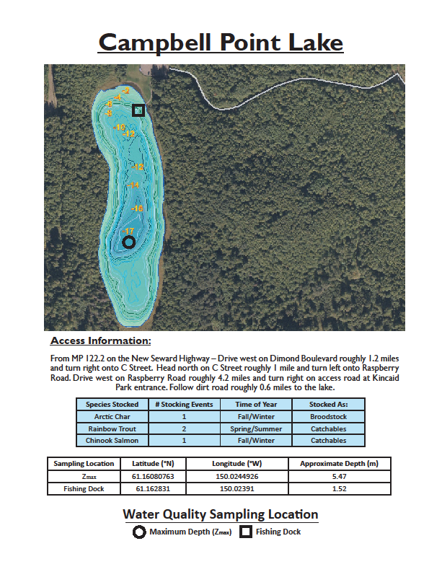

Appendix B2.–Bathymetric map and basic information for Cheney Lake in the AMA.

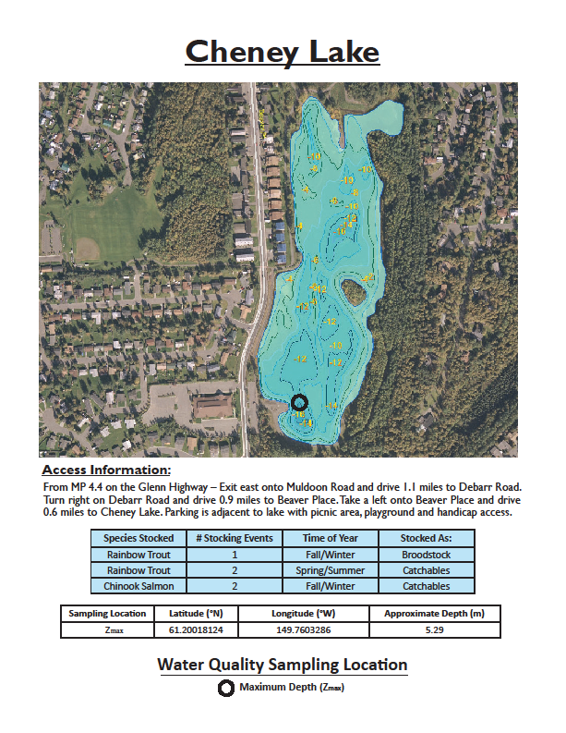

Appendix B3.–Bathymetric map and basic information for DeLong Lake in the AMA.

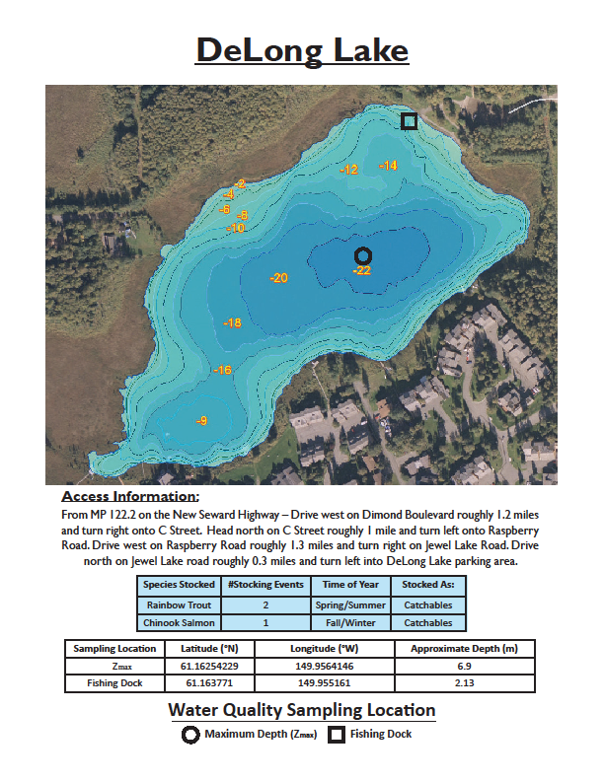

Appendix B4.–Bathymetric map and basic information for Gravel Pit Lake in the AMA.

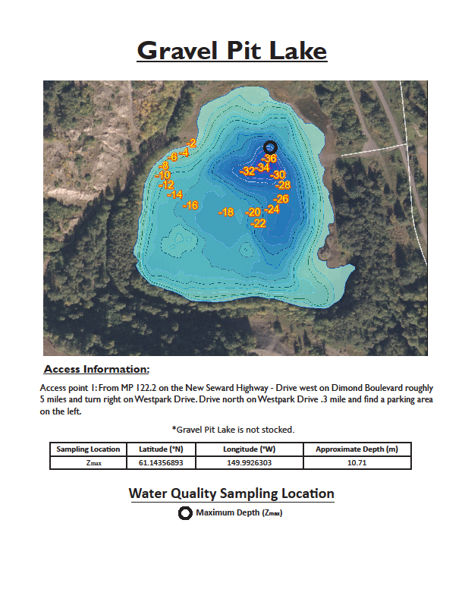

Appendix B5.–Bathymetric map and basic information for Jewel Lake in the AMA.

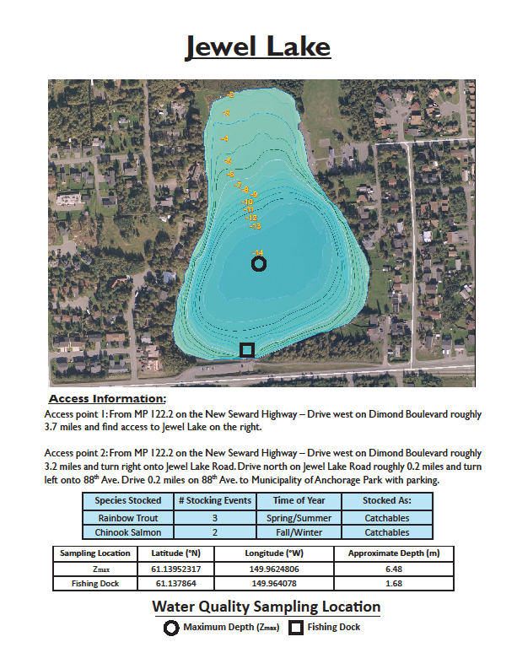

Appendix B6.–Bathymetric map and basic information for Lower Fire Lake in the AMA.

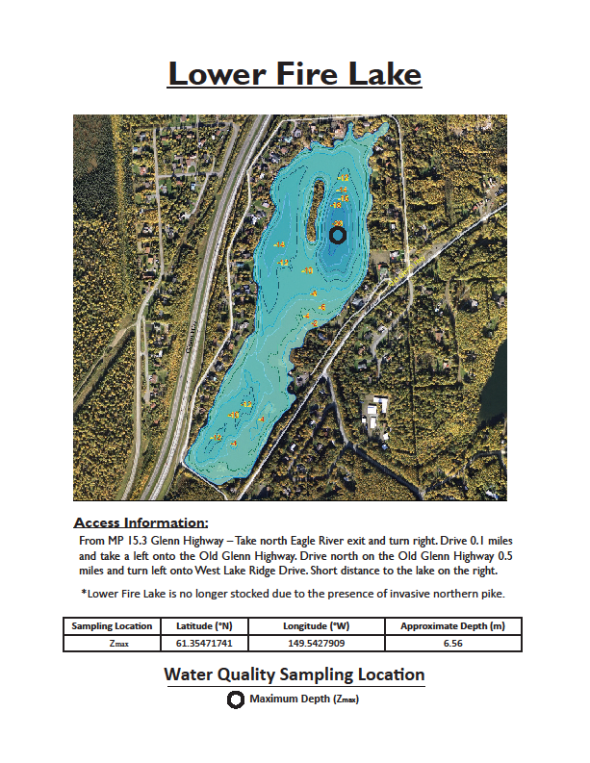

Appendix B7.–Bathymetric map and basic information for Mirror Lake in the AMA.

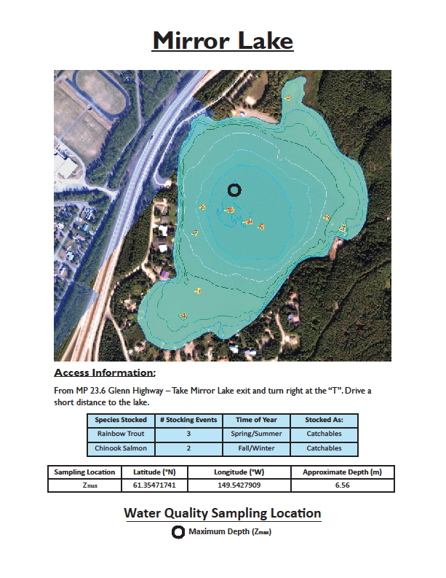

Appendix B8.–Bathymetric map and basic information for Sand Lake in the AMA.

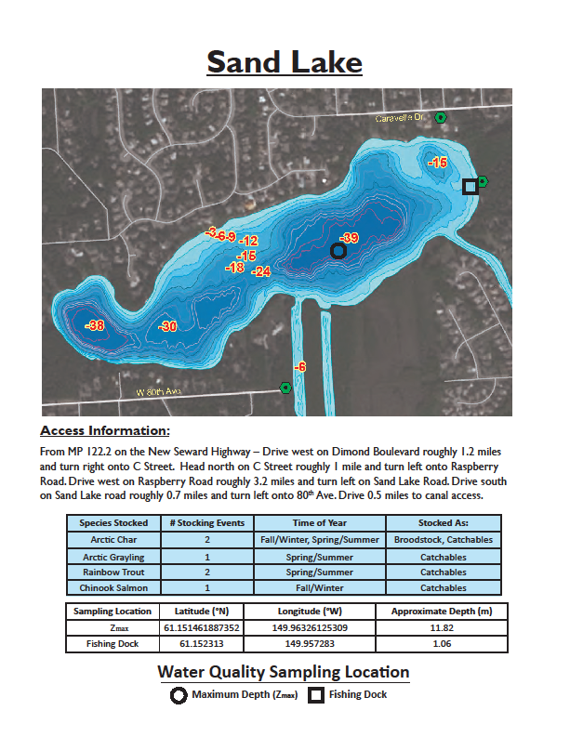

Appendix B9.–Bathymetric map and basic information for Waldron Lake in the AMA.

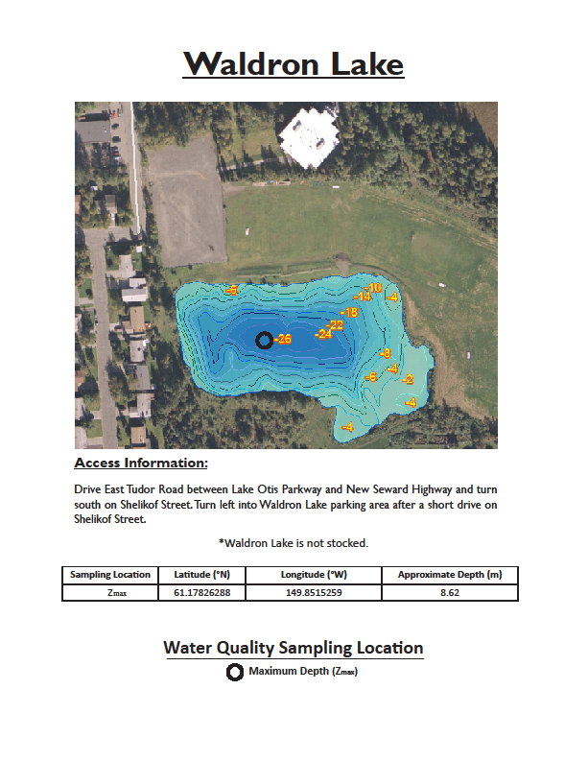

# Appendix C: Lake assessment data forms

Appendix C1.–Datasheet used to record water quality measurement.



Appendix C2.–Datasheet used to record data on individually captured fish and for recording netting effort and gear type.

|  |  |  |
| --- | --- | --- |
|  |  |  |
| **Date:_____________________** | **Samplers:__________________** | **Lat:________________________** |
| **Lake:____________________** | **Gear Type:_________________** | **Long:______________________** |

|  |  |  |
| --- | --- | --- |
| Start Time:__________ | Set Date:____________ |  |
| End  Time: __________ | Pull Date:___________ | **Total Fishing Time (hrs) :________** |

Depth (m):______ Weather:____________________________________________

Water Temperature (°C):______

Remarks:_____________________________________________________________________________

|  |  |  |  |  |  |  |
| --- | --- | --- | --- | --- | --- | --- |
| **Sample** | **Species** | **Length (FL)** | **Weight (grams)** | **Card#/ Scale#** | **Floy Tag Number** | **Notes**  **(Health, Abnormalities, etc.)** |
| **1** |  |  |  |  |  |  |
| **2** |  |  |  |  |  |  |
| **3** |  |  |  |  |  |  |
| **4** |  |  |  |  |  |  |
| **5** |  |  |  |  |  |  |
| **6** |  |  |  |  |  |  |
| **7** |  |  |  |  |  |  |
| **8** |  |  |  |  |  |  |
| **9** |  |  |  |  |  |  |
| **10** |  |  |  |  |  |  |
| **11** |  |  |  |  |  |  |
| **12** |  |  |  |  |  |  |
| **13** |  |  |  |  |  |  |
| **14** |  |  |  |  |  |  |
| **15** |  |  |  |  |  |  |
| **16** |  |  |  |  |  |  |
| **17** |  |  |  |  |  |  |
| **18** |  |  |  |  |  |  |
| **19** |  |  |  |  |  |  |
| **20** |  |  |  |  |  |  |

|  |  |  |  |
| --- | --- | --- | --- |
| **Fish Species Codes** Rainbow trout- RT | Coho salmon- CS | Longnose sucker- CC | Nine-spined stickleback- NSS |
| Chinook salmon- KS | Northern pike- NP | Arctic grayling- AG | Three-spined stickleback- TSS |
| Arctic char- AC | Alaska blackfish- BF | Sculpins- SCL |  |

Appendix C3.–Datasheet used to record a tally of total catch by species and fishing time for each piece of sampling gear.

**Anchorage Stocked Lakes Page:____ of ____  
Captured Fish Tally**

**Date(s):__________________________________ Lake:____________________________________   
Gear Type:_______________________ Soak Time:_________________________ Net/Trap Number:_____________  
GPS:_______________________________________________ Samplers:_______________________________________**

|  |  |  |  |
| --- | --- | --- | --- |
| **Species** | **Tally** | **Number of Fish Sampled** | **Notes** |
|  |  |  |  |
|  |  |  |  |
|  |  |  |  |
|  |  |  |  |
|  |  |  |  |
|  |  |  |  |
|  |  |  |  |
|  |  |  |  |
|  |  |  |  |
|  |  |  |  |
|  |  |  |  |
|  |  |  |  |

|  |  |  |  |
| --- | --- | --- | --- |
| **Fish Species Codes** Rainbow trout- RT | Coho salmon- CS | Longnose sucker- CC | Nine-spined stickleback- NSS |
| Chinook salmon- KS | Northern pike- NP | Arctic grayling- AG | Three-spined stickleback- TSS |
| Arctic char- AC | Alaska blackfish- BF | Sculpins- SCL |  |

Appendix C4.–Datasheets used to record macroinvertebrate collection and identification data.



Appendix C5.–Datasheet used to record stomach contents for prey assessment.

|  |  |  |  |  |  |  |  |  |
| --- | --- | --- | --- | --- | --- | --- | --- | --- |
| **Prey Consumption Datasheet** | | | |  |  |  |  |  |
| **Location:_______________________________________** | | | |  |  |  |  |  |
| **Sampling Date:_______________________________________** | | | |  |  |  |  |  |
|  |  |  |  |  |  |  |  |  |
|  |  |  | Collection Type | Prey Items Found | | | | |
| Fish # | Spp. | Length (mm) | (Pump or Dissection) | I | II | III | IV | V |
|  |  |  |  |  |  |  |  |  |
|  |  |  |  |  |  |  |  |  |
|  |  |  |  |  |  |  |  |  |
|  |  |  |  |  |  |  |  |  |
|  |  |  |  |  |  |  |  |  |
|  |  |  |  |  |  |  |  |  |
|  |  |  |  |  |  |  |  |  |
|  |  |  |  |  |  |  |  |  |
|  |  |  |  |  |  |  |  |  |
|  |  |  |  |  |  |  |  |  |
|  |  |  |  |  |  |  |  |  |
|  |  |  |  |  |  |  |  |  |
|  |  |  |  |  |  |  |  |  |
|  |  |  |  |  |  |  |  |  |
|  |  |  |  |  |  |  |  |  |
|  |  |  |  |  |  |  |  |  |
|  |  |  |  |  |  |  |  |  |

|  |  |  |  |
| --- | --- | --- | --- |
| **Fish Species Codes** Rainbow trout- RT | Coho salmon- CS | Longnose sucker- CC | Nine-spined stickleback- NSS |
| Chinook salmon- KS | Northern pike- NP | Arctic grayling- AG | Three-spined stickleback- TSS |
| Arctic char- AC | Alaska blackfish- BF | Sculpins- SCL |  |

1. Alaska Department of Fish and Game (ADF&G). 2017. Statewide stocking plan. Region II – Southcentral. http://www.adfg.alaska.gov/index.cfm?adfg=fishingSportStockingHatcheries.stockingPlan. (Accessed May 2017).
2. Product names used in this publication are for completeness and do not constitute product endorsement.